Variables are measurable characteristics that vary across observations. They form the analytical core of research.
Variables are generally categorized as:

  - Independent variables
  - Dependent variables
  - Control variables
  - Moderator variables
  - Mediator variables
Independent Variables : Independent variables are manipulated or categorized to observe their effect.
Example: Caching strategy (enabled vs. disabled)
Dependent Variables : Dependent variables measure outcomes affected by independent variables.
Example: Average query response time
Control Variables : Control variables are held constant to prevent confounding effects.
Example:
Hardware configuration
Dataset size
Network bandwidth
Moderator Variables : Moderators influence the strength or direction of the relationship between independent and dependent variables.
Example: Concurrency level may moderate the impact of caching on latency.
Mediator Variables : Mediators explain the mechanism through which an independent variable influences a dependent variable.
Example: Caching reduces database access frequency, which in turn reduces latency.
Variables differ not only by type but also by measurement scale. Measurement levels determine permissible statistical operations.
The four primary levels include:

  - Nominal
  - Ordinal
  - Interval
  - Ratio
Nominal Scale : Categorical variables without intrinsic order.
Example: Operating system type (Linux, Windows, macOS)
Ordinal Scale : Categorical variables with order but no equal interval.
Example: User satisfaction level (Low, Medium, High)
Interval Scale : Numeric variables with equal intervals but no true zero.
Example: Temperature in Celsius
Ratio Scale : Numeric variables with equal intervals and true zero.
Example:
Execution time (milliseconds)
Number of security breaches
Measurement level determines appropriate statistical analysis. For example, mean calculations require interval or ratio data, while nominal data require frequency analysis.

Research often examines relationships among variables. These relationships may be:

  - Causal
  - Correlational
  - Comparative
A conceptual model visually represents these relationships before empirical testing.
For example: Caching Strategy → Reduced Database Calls → Lower Latency
A conceptual model clarifies:

  - Direction of influence
  - Expected relationships
  - Analytical framework
Conceptual modeling ensures logical coherence before data collection begins.

Common Errors in Conceptualization and Variable Definition
Errors at this stage compromise research validity. Common issues include:

  - Ambiguous conceptual definitions
  - Lack of operational clarity
  - Confusion between independent and dependent variables
  - Ignoring control variables
  - Inconsistent measurement scales
For example, measuring “system performance” through user satisfaction surveys without defining performance metrics introduces conceptual inconsistency. Rigorous conceptualization strengthens research validity and analytical credibility.

Research Variables 101: Dependent, Independent, Control Variables & More

Discussion : Formulation of the Research Problem

Level 2 headings may be created by course providers in the future.

Choose at least one of the following questions and post your opinion about it on the discussion board under “Chapter 2: Formulation of the Research Problem”. Alternatively, you can also add a response to one of the posts made by your classmates.

  - How does literature review strengthen problem formulation?
  - What risks arise from poorly defined variables?
  - Why is operational definition critical in IT research?
  - Why must objectives align strictly with hypotheses?
You can click here to go to the discussion page.

The research process in Information Technology is the discipline of organizing inquiry into a logically sequenced and methodologically aligned framework. In this chapter, research is presented as a structured progression that integrates contextual justification, thematic synthesis of literature, and detailed planning of procedures and analytical strategies. Emphasis is placed on coherence among research questions, methodological choices, instrumentation, and analysis frameworks. This framing matters because systematic organization ensures that investigations are internally consistent, ethically grounded, and capable of producing credible results.
By the end of this chapter, students will be able to:

  - Articulate a structured research problem with context and justification.
  - Organize and synthesize literature thematically.
  - Plan procedures, instrumentation, and analysis frameworks.

Structural Components of a Research Problem

Level 2 headings may be created by course providers in the future.
A research problem represents a precisely defined issue requiring systematic investigation. It establishes intellectual direction and determines methodological boundaries. A research problem is not equivalent to a general topic or a technological inconvenience; it is a structured statement describing a gap in knowledge, inconsistency in findings, theoretical limitation, or measurable inefficiency.
In Information Technology research, problems frequently arise from observable variations in system behavior, unexplained performance discrepancies, unresolved security vulnerabilities, or theoretical contradictions in computational models. However, these observations must undergo analytical refinement before they become research problems.
A research problem consists of interrelated structural elements that ensure analytical coherence.
The first element is contextual grounding. Context situates the problem within a defined technological or theoretical domain. Without context, the problem lacks interpretive framework.
The second element is the identification of deficiency or gap. A deficiency may take the form of insufficient empirical validation, contradictory findings across studies, or absence of contextual evaluation. For example, distributed caching mechanisms may demonstrate performance improvements in enterprise environments, yet empirical evaluation under bandwidth-constrained institutional infrastructures may remain limited.
The third element is justification for investigation. Justification explains why the identified deficiency requires systematic study. Significance may arise from theoretical advancement, technological optimization, or institutional necessity.
When these structural elements are articulated clearly, the research problem becomes analytically precise and methodologically actionable.
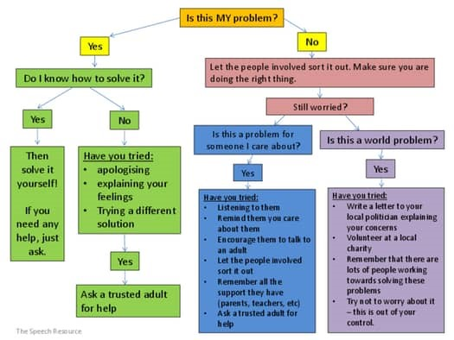
Figure 1 : Logical Structure of Research Problem Articulation

Criteria for Evaluating the Quality of a Research Problem

A research problem must satisfy specific intellectual criteria in order to sustain rigorous investigation. These criteria ensure methodological feasibility, analytical precision, and scholarly contribution. The major evaluative criteria include:

  - Clarity
  - Specificity
  - Feasibility
  - Significance
  - Researchability
Each criterion functions as a filter that prevents conceptual weakness from propagating into later stages of research design.
Clarity
Clarity requires explicit definition of central constructs and avoidance of ambiguous language. A research problem must communicate its focus without interpretive uncertainty. For instance, stating that a system exhibits “poor performance” introduces ambiguity unless performance is defined in measurable terms such as response latency, throughput rate, or memory utilization. Conceptual clarity ensures that readers, evaluators, and researchers share the same understanding of the issue under investigation.
Specificity
Specificity narrows the scope of inquiry to manageable and measurable dimensions. Overly broad research problems lack methodological direction and often produce superficial findings. A specific problem defines contextual boundaries, system parameters, and measurable outcomes. For example, instead of addressing “cloud efficiency,” a specific formulation may examine “the impact of dynamic resource allocation thresholds on response latency in institutional cloud environments during peak usage periods.” Specificity enhances analytical depth and prevents scope expansion beyond feasible limits.
Feasibility
Feasibility concerns the practical possibility of conducting the investigation within available constraints. It involves evaluation of data access, technical infrastructure, time availability, computational capacity, and ethical approval requirements. A problem that requires proprietary datasets or large-scale distributed infrastructure beyond accessible resources lacks feasibility. Rigorous feasibility assessment prevents premature research failure and ensures realistic procedural planning.
Significance
Significance determines the intellectual or practical value of the research problem. A problem gains significance when it contributes to theoretical advancement, technological optimization, policy development, or institutional improvement. Significance may also derive from addressing unresolved contradictions within existing literature. Research lacking significance may be methodologically sound yet intellectually trivial.
Researchability
Researchability ensures that the problem can be examined empirically. A researchable problem allows operationalization into measurable variables and systematic analysis. Questions that cannot be translated into observable indicators fall outside empirical research domains. Researchability links conceptual formulation with analytical execution.
Collectively, these criteria determine whether a research problem possesses sufficient intellectual strength to support structured inquiry.

Logical Articulation of a Research Problem

Articulation converts conceptual identification into formal academic expression. The structure of articulation determines whether the research problem is interpretable, coherent, and analytically actionable.
A well-articulated research problem follows a logical progression of:
1. Contextual framing
2. Identification of deficiency or gap
3. Evidence of insufficiency in prior research
4. Explicit statement of investigative intent
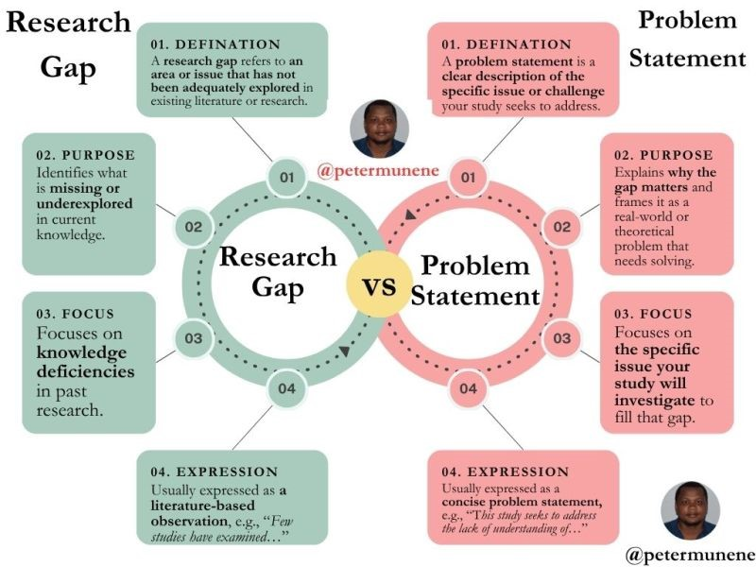
Figure 2 : Expanded Framework for Research Problem Formulation
Contextual framing situates the problem within a defined technological or theoretical environment. This establishes interpretive boundaries and prevents abstraction without grounding.
The identification of deficiency clarifies what remains uncertain or inadequately examined. Deficiency may manifest as contradictory findings, insufficient contextual testing, or absence of empirical validation.
Evidence of insufficiency requires reference to prior scholarship. Demonstrating that existing studies do not fully resolve the issue strengthens justification for investigation.
The final stage articulates investigative intent in precise language. This stage must avoid generality and instead define measurable direction.
For example:
Prior studies have demonstrated that distributed caching improves performance in enterprise-scale cloud environments. However, empirical evaluation under bandwidth-constrained institutional infrastructures remains limited. Variability in concurrency patterns within academic systems suggests potential differences in performance outcomes. The present study evaluates the effect of distributed caching on average query response latency under peak institutional workload conditions.
Expanded articulation strengthens coherence between conceptual recognition and methodological planning.

Distinguishing Research Problems from Operational Issues
Operational issues involve immediate technical malfunction or configuration deficiencies. These issues are resolved through diagnostic troubleshooting rather than systematic investigation. Research problems, by contrast, seek to identify underlying mechanisms, patterns, or theoretical relationships that extend beyond isolated incidents.
For example, correcting a database misconfiguration constitutes operational maintenance. Investigating whether recurring misconfigurations across institutional deployments arise from architectural design flaws constitutes research.
The distinction lies in scope and generalizability. Operational issues address singular events. Research problems aim to establish replicable findings and conceptual insight applicable beyond specific cases.
Confusing these categories reduces research to routine system maintenance. Clear differentiation preserves scholarly purpose and theoretical contribution

Theoretical Grounding and Conceptual Orientation

Literature review constitutes a foundational stage in the research process. It establishes the intellectual environment within which the study is positioned. A research project without a rigorous literature review lacks theoretical grounding, risks duplication, and may misalign with established methodological standards. Literature review performs analytical, evaluative, and integrative functions that collectively strengthen research coherence.
The literature review in the research process extends beyond topic familiarization. It systematically examines existing scholarship to clarify conceptual frameworks, methodological approaches, empirical findings, and unresolved questions. Through structured synthesis, it identifies patterns of agreement, areas of divergence, and domains requiring further investigation.
The primary function of a literature review is to establish theoretical grounding by situating a research problem within existing concepts and models. In Information Technology, this may involve frameworks such as computational complexity theory, network architecture models, machine learning theory, human–computer interaction, or cybersecurity paradigms. These theories define key constructs and clarify relationships among variables.
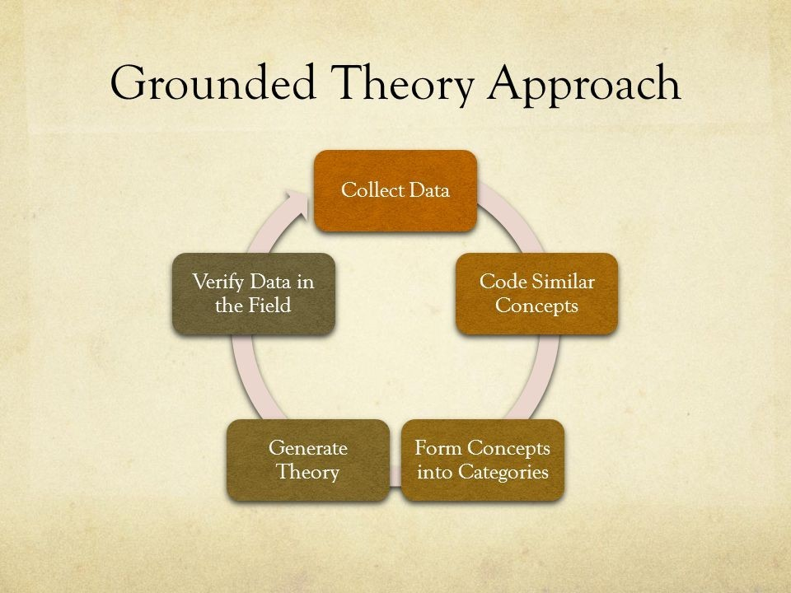
Figure 3 : Grounded Theory Approach
Theoretical grounding prevents conceptual ambiguity and ensures that terms such as performance, efficiency, or scalability are defined consistently within established scholarship. Without it, research findings remain isolated observations rather than meaningful contributions to cumulative knowledge.
Additionally, theory guides hypothesis development by predicting expected relationships between variables. For example, queueing theory suggests that increasing user concurrency without scaling resources increases response latency. Thus, a strong literature review provides conceptual clarity, direction, and interpretive depth for research.

Systematic Organization and Analytical Structuring of Literature
Effective literature review requires systematic organization. Disorganized presentation of studies obscures conceptual relationships and weakens scholarly argumentation. Structured organization enhances clarity and analytical progression.
Literature may be organized according to thematic similarity, methodological approach, theoretical framework, or chronological development. Thematic organization groups studies addressing similar constructs or phenomena. Methodological organization compares experimental designs, sampling strategies, or analytical techniques. Theoretical organization clusters studies grounded in similar conceptual models. Chronological organization traces the evolution of ideas over time.
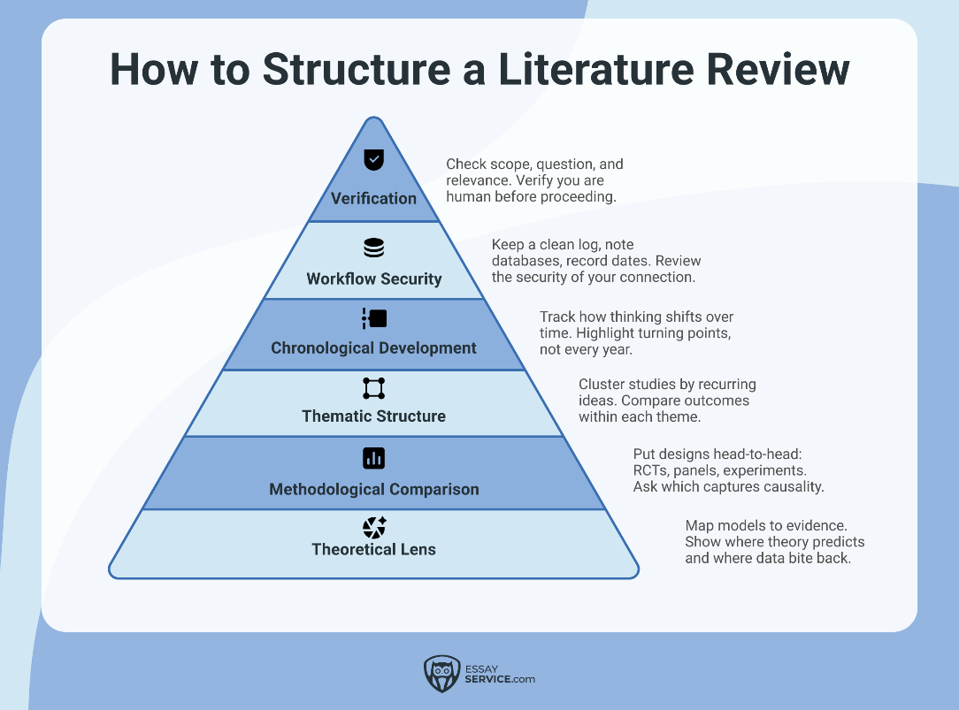
Figure 4 : Systematic Organization Models for Literature Review
Structured organization supports comparative analysis. Comparative analysis identifies similarities and differences across studies in terms of design, context, measurement, and findings. For example, studies evaluating caching performance may vary according to workload simulation, infrastructure scale, and measurement metrics. Comparing these variations clarifies contextual dependencies and methodological limitations.
Systematic organization also facilitates gap identification. When studies consistently omit certain contexts or variables, a structural gap becomes visible. Analytical structuring transforms literature review from descriptive summary into evaluative synthesis.

Critical Evaluation of Scholarly Sources

Literature review requires critical evaluation rather than passive acceptance of findings. Critical evaluation examines methodological rigor, sampling adequacy, measurement validity, and analytical robustness.
Methodological rigor refers to the degree to which research design minimizes bias and ensures reliability. Experimental control, statistical adequacy, and transparent reporting contribute to rigor. Sampling adequacy influences generalizability. Limited or non-representative samples restrict external validity.
Measurement validity concerns whether instruments accurately capture intended constructs. For example, using subjective perception surveys to measure objective system performance introduces validity concerns unless carefully justified.
Analytical robustness examines whether statistical methods or interpretive procedures are appropriate for variable type and research design. Misapplication of statistical tests may produce misleading conclusions.
Critical evaluation allows identification of methodological strengths and weaknesses across studies. It also informs methodological choices in the current research. Recognizing limitations in prior studies enables refinement and improvement of new investigation.
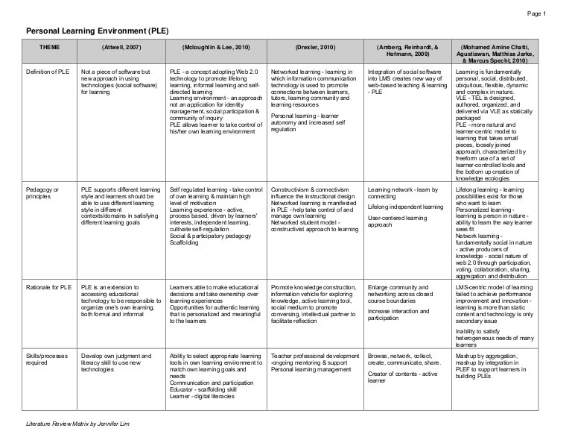
Figure 5 : Comparative Analytical Structuring of Scholarly Literature

Synthesis and Integration of Findings
Synthesis represents the highest level of literature review. It integrates findings across studies into coherent analytical patterns. Synthesis identifies converging results, divergent conclusions, and unresolved inconsistencies.
Converging findings strengthen theoretical confidence. Divergent findings indicate potential contextual variability or methodological inconsistency. Unresolved inconsistencies signal areas requiring further empirical clarification.
Synthesis involves comparative interpretation rather than sequential reporting. Instead of listing studies individually, synthesis integrates findings into thematic clusters.
For example, studies may consistently demonstrate caching effectiveness in enterprise cloud environments while reporting mixed results in bandwidth-limited contexts. This integrated observation reveals a contextual dependency that warrants focused investigation.
Synthesis clarifies the intellectual contribution of the new study. It defines how the research extends existing scholarship by addressing identified gaps or resolving contradictions.

Literature Review as Foundation for Research Design
Literature review directly informs research design decisions. Prior scholarship provides evidence regarding effective measurement instruments, appropriate sampling strategies, and validated analytical techniques.
For example, performance benchmarking studies may indicate that latency measurements require controlled workload generation tools. Security studies may reveal the necessity of penetration testing frameworks. Usability research may demonstrate reliability of standardized survey instruments such as the System Usability Scale.
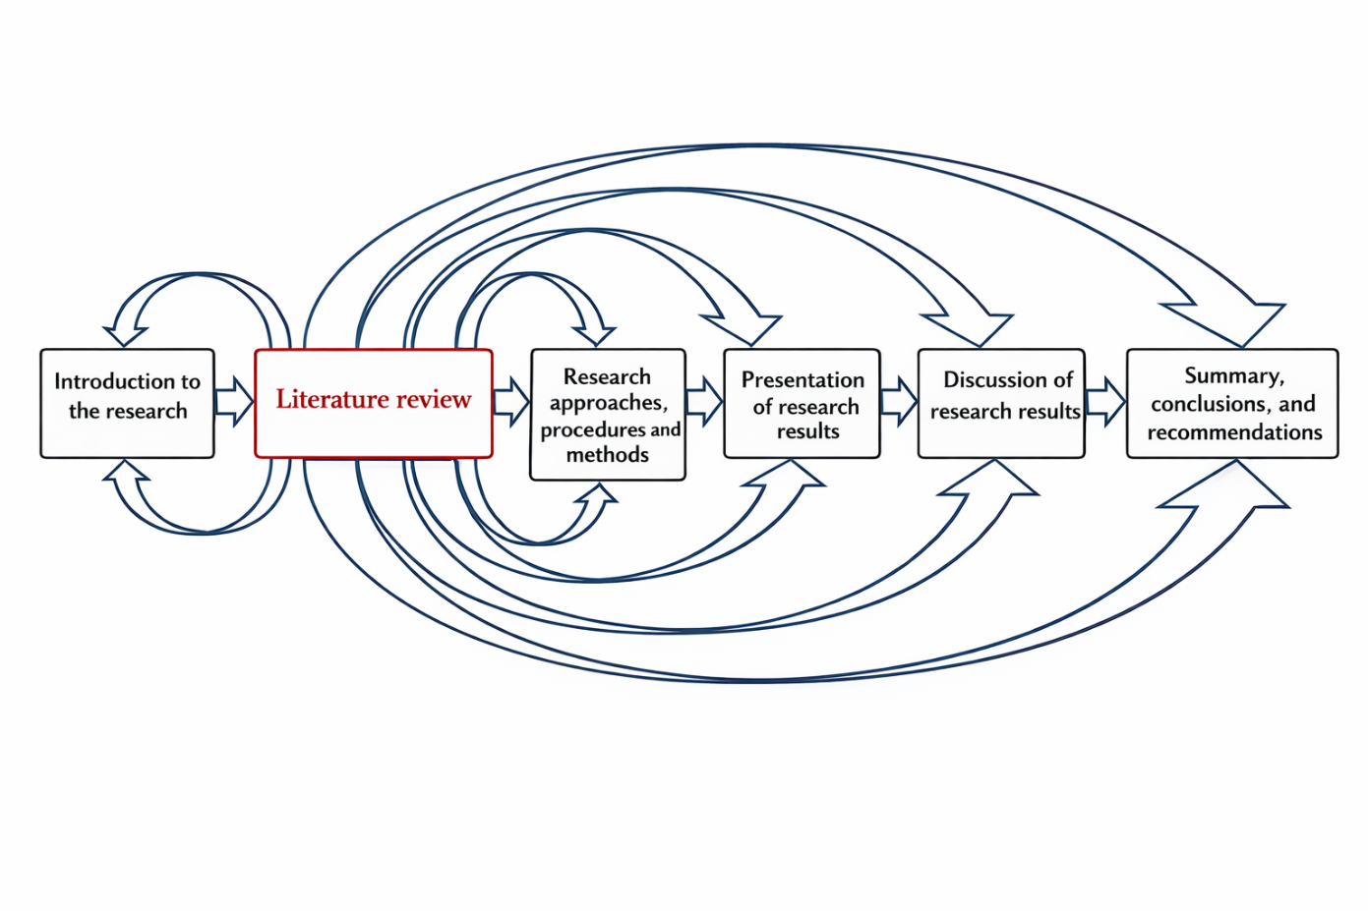
Figure 6 : Literature Review as Foundation for Research Design Decisions
Literature-informed design enhances methodological legitimacy. It prevents adoption of inappropriate analytical methods and strengthens alignment between research objectives and procedural execution.
Furthermore, literature review establishes boundaries of generalization. Understanding contextual conditions under which prior findings were derived informs interpretation of new results.
Literature review therefore functions not only as conceptual foundation but also as methodological guide.

Selection and Justification of Research Design

Procedural determination transforms conceptual formulation into structured implementation. This stage defines how the research will be conducted, measured, analyzed, and evaluated. Procedural clarity ensures methodological transparency and replicability.
Research design establishes the strategic framework guiding investigation. It defines the structure within which variables are measured and relationships are analyzed.
Design selection must align with research objectives and hypothesis structure. Experimental designs are appropriate when variable manipulation is feasible and causal relationships are investigated. Survey designs are suitable for perception-based measurement. Case study designs facilitate in-depth contextual analysis. Simulation-based designs allow modeling of computational behavior under controlled conditions.
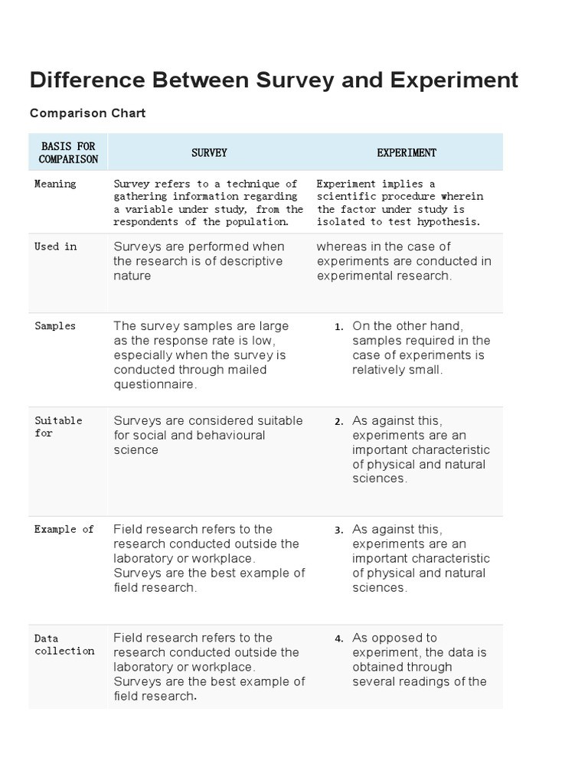
Figure 7 : Typology of Research Designs and Their Strategic Alignment
Justification of design choice requires explanation of how the selected design best addresses the research problem. For example, evaluating caching performance under controlled concurrency levels may require experimental or simulation design rather than survey methodology.
Design justification strengthens methodological credibility.

Sampling Strategy and Population Definition

Level 2 headings may be created by course providers in the future.

Sampling defines how units of analysis are selected from a broader population. In IT research, units of analysis may include datasets, system configurations, network environments, or user groups.
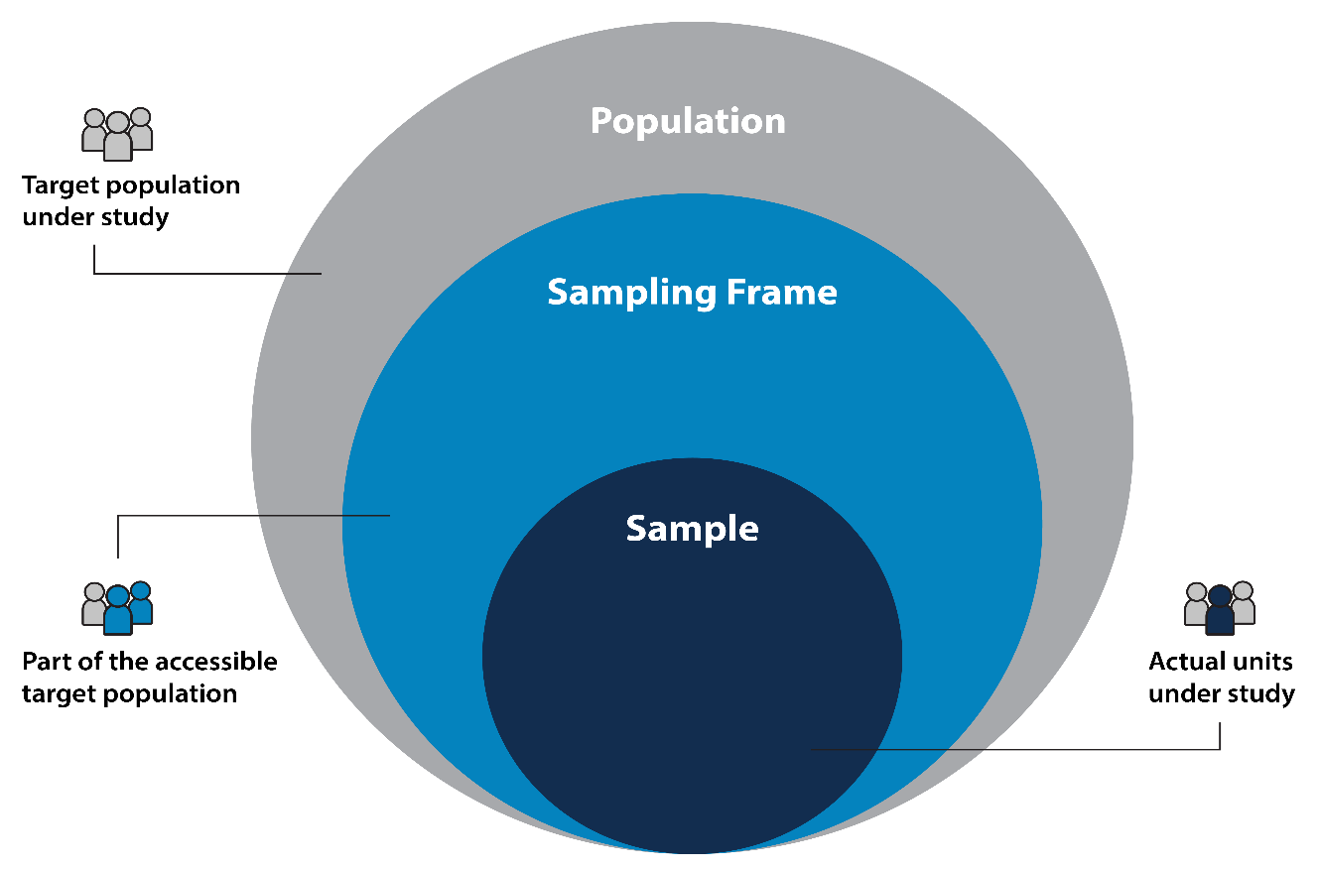
Figure 8 : Relationship between Population, Sampling Frame, Sample
Population definition establishes boundaries of generalization. Sampling strategy must ensure representativeness where generalization is intended. For example, selecting only low-traffic periods when evaluating system performance may bias conclusions.
Sampling methods must align with research objectives and minimize systematic error. Procedural documentation of sampling criteria enhances replicability and external validity.

Data Collection and Processing
Instrumentation and Data Collection Procedures
Instrumentation refers to tools or mechanisms used for data collection. In computational research, instruments may include benchmarking software, monitoring tools, logging systems, or survey instruments.
Data collection procedures must define:

    - Measurement frequency
    - Environmental conditions
    - Control mechanisms
    - Calibration procedures
Consistency in data collection ensures measurement reliability. For example, latency measurement must be conducted under standardized workload conditions to prevent confounding variability.
Detailed procedural description enables replication and methodological transparency.

Analytical Framework and Data Processing
Analytical framework determines how collected data will be processed and interpreted. The framework must align with hypothesis structure and measurement level.
Quantitative analysis may involve statistical testing, regression modeling, variance analysis, or performance benchmarking. Qualitative analysis may involve thematic coding or interpretative categorization.
Alignment between variable type and statistical technique ensures valid inference. For example, ratio-scale latency measurements permit parametric testing, while ordinal survey responses may require non-parametric methods.
Analytical rigor ensures that conclusions derive logically from measured evidence.

Ethical Safeguards and Feasibility Evaluation
Procedural planning incorporates ethical safeguards to protect data integrity and participant rights. Data privacy measures, secure storage protocols, and informed consent procedures must be defined where applicable.
Feasibility evaluation examines whether procedural steps can be realistically executed within time, infrastructure, and institutional constraints. Unrealistic procedural complexity may compromise completion or validity.
Comprehensive procedural description integrates methodological precision, ethical responsibility, and practical realism.

The Scientific Method: Steps, Examples, Tips, and Exercise

Conceptual Foundations of Research Design

Research design refers to the overall plan that integrates research objectives with procedural implementation. It determines how variables are structured, how relationships are examined, and how evidence is generated to answer research questions. Design provides logical continuity between conceptual formulation and empirical execution.
Research design functions as a methodological blueprint. It anticipates how data will be generated and how causal or relational inferences will be drawn. A design must align with the type of research question being investigated. If the objective is to determine causal impact, the design must incorporate control mechanisms. If the objective is exploratory, the design must allow flexibility and contextual sensitivity.
The integrity of research design depends on alignment between variables and investigative strategy. For example, when examining the impact of caching strategies on system latency, the design must specify how caching is manipulated or observed, under what workload conditions, and how latency is measured.
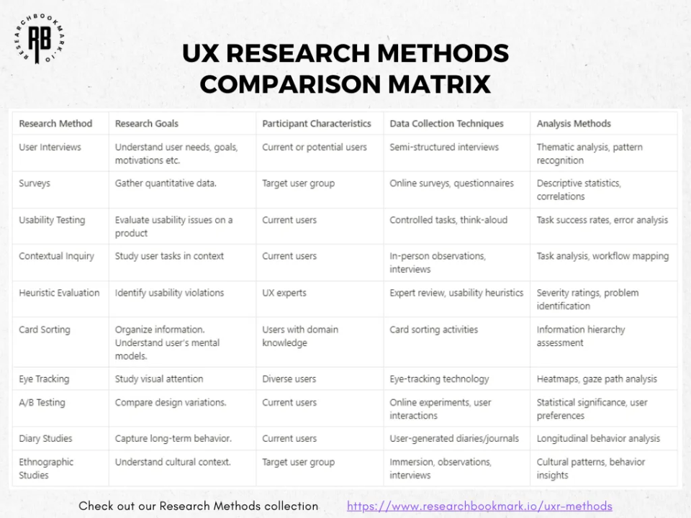
Figure 1 : Structural Relationship Between Research Objectives, Variables, and Design Strategy
Research design also incorporates mechanisms to address threats to validity. Confounding variables, measurement error, and selection bias must be anticipated during design formulation rather than addressed retrospectively. A clearly articulated design enhances methodological transparency and facilitates replication.

Categories of Research Design
Research designs can be broadly classified into experimental, quasi-experimental, and non-experimental forms. Each category reflects differing levels of control over independent variables and contextual conditions.
Experimental design involves deliberate manipulation of independent variables while controlling extraneous influences. This design allows stronger causal inference because observed effects can be attributed to controlled variation. In Information Technology research, experimental designs are common in algorithm benchmarking, performance comparison under controlled loads, and security vulnerability testing within isolated environments.
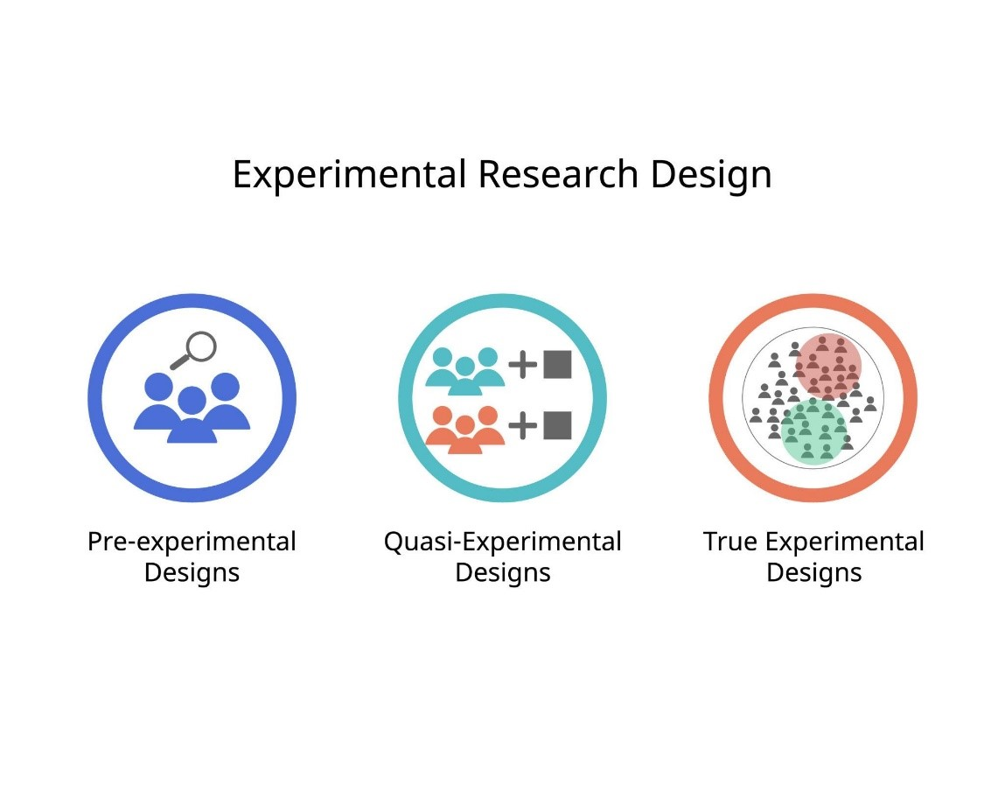
Figure 2 : Comparative Framework of Experimental, Quasi-Experimental, and Non-Experimental Research Designs
Quasi-experimental design involves comparison across groups or conditions without full randomization or control. While causal inference is more limited, quasi-experimental approaches are often practical when environmental constraints restrict full manipulation. For example, evaluating system performance across naturally occurring institutional settings may require quasi-experimental comparison.
Non-experimental design includes observational, correlational, case study, and survey research. These designs examine relationships without manipulating independent variables. Correlational designs may investigate associations between concurrency levels and system performance. Case studies may provide in-depth examination of specific deployments.
The selection of design must be justified through alignment with objectives and feasibility constraints.

Validity Considerations in Research Design
Validity determines whether research conclusions accurately reflect reality. Internal validity concerns whether changes in the dependent variable result from manipulation of the independent variable rather than uncontrolled influences. For example, when evaluating caching strategies, variations in hardware configuration may confound results if not controlled.
External validity concerns the generalizability of findings beyond the immediate study environment. A highly controlled laboratory experiment may produce internally valid results that lack applicability to real-world institutional systems.
Construct validity addresses whether measurement accurately represents conceptual variables. If system performance is operationalized through inappropriate indicators, construct validity is compromised.
Design planning must incorporate strategies to strengthen validity, including randomization where possible, control groups, consistent measurement procedures, and transparent reporting.

Understanding Research Design

What is Sampling?

What is Sampling?
Sampling determines how empirical observations are selected from a defined population. The integrity of sampling directly influences the credibility of statistical inference, generalizability of findings, and interpretive validity of conclusions. Inadequate sampling procedures introduce bias that cannot be corrected during analysis.
In Information Technology research, sampling may involve selection of datasets, system configurations, network environments, user groups, or time periods. Unlike purely social science research, IT sampling frequently involves both human and non-human units of analysis. For example, sampling may include:
• Server clusters
• Database instances
• Application deployments
• User session logs
• Network traffic intervals
The methodological rigor of sampling determines the boundary of generalization.

Defining Population and Sampling Frame
A population represents the complete set of elements to which research conclusions are intended to apply. Population definition requires conceptual clarity. For example, if the research investigates performance of distributed caching in institutional cloud systems, the population must specify:
• Type of institutions
• Nature of infrastructure
• Geographic or bandwidth constraints
• Deployment architecture
Without explicit population definition, generalization becomes ambiguous.
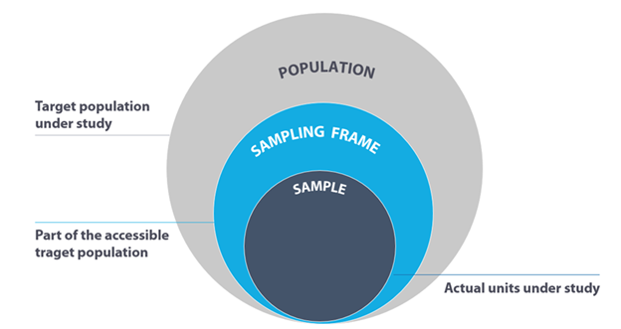
Figure 3 : Relationship between Population, Sampling Frame, Sample
The sampling frame represents the accessible portion of that population. Discrepancies between the population and the sampling frame introduce coverage error. For instance, if only high-performance institutional servers are included in the sampling frame, findings cannot be generalized to lower-capacity deployments.
Careful articulation of both population and sampling frame ensures that conclusions are interpreted within defined boundaries.

Probability Vs Non-Probability Sampling

Probability Sampling
Probability sampling ensures that each element within the defined population has a known and non-zero probability of selection. This characteristic allows estimation of sampling error and strengthens inferential validity.
Simple random sampling involves selection through randomization procedures that minimize selection bias. Stratified sampling divides the population into subgroups based on relevant characteristics before sampling proportionally from each stratum. In IT research, strata may include different concurrency levels, hardware configurations, or institutional categories.
Cluster sampling may involve selecting entire server clusters or institutional units as primary sampling units. Systematic sampling may involve selecting every nth log entry or transaction event.
Probability sampling enhances representativeness but may require comprehensive sampling frames and greater logistical effort.
Non-Probability Sampling
Non-probability sampling does not guarantee equal selection probability. However, it may be appropriate when probability sampling is impractical or when research is exploratory in nature.
Convenience sampling may involve selecting accessible system logs or available performance datasets. Purposive sampling may involve deliberately selecting specific system configurations to test targeted hypotheses. Quota sampling may involve ensuring proportional representation of predefined categories.
Non-probability sampling requires explicit acknowledgment of limitations. External validity may be restricted, but analytical depth within the selected sample may still yield valuable insights.
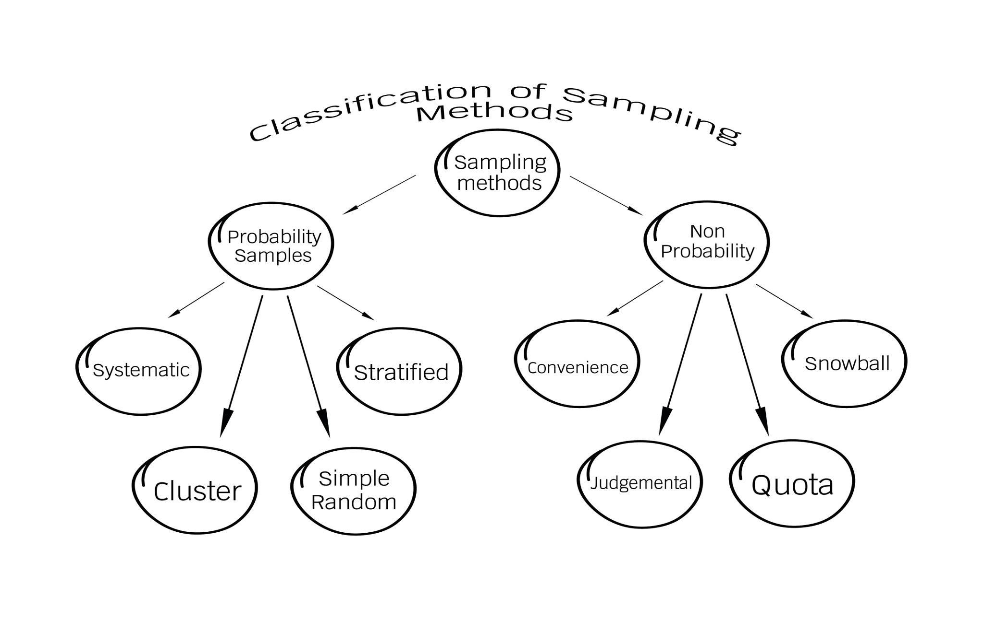
Figure 4 : Population, Sampling Frame, and Sample Selection Process Model
Sampling transparency allows evaluators to assess generalizability and potential bias.

What Are The Types Of Sampling Techniques In Statistics?

The Need to Measure, Conceptualization and Operationalization

Level 2 headings may be created by course providers in the future.

Why measure?
Measurement provides the bridge between theoretical constructs and empirical evidence. It involves assigning values to variables according to defined rules and procedures. The quality of measurement determines whether research conclusions are credible.
Measurement must follow a structured progression:
1. Conceptual clarification
2. Operational definition
3. Instrument selection
4. Data capture
5. Error control
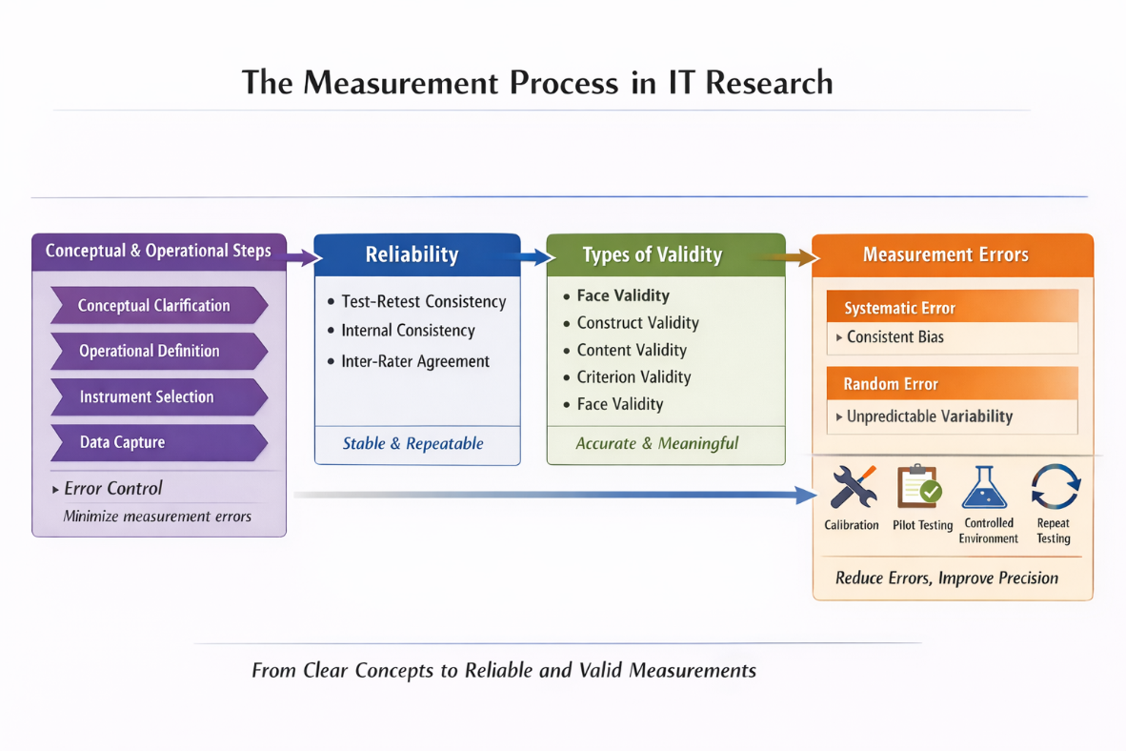
Figure 5 : From Clear Concepts to Reliable and Valid Measurements
Without precision at each stage, empirical findings lack interpretive validity.

Conceptualization and Operationalization
Conceptualization defines what is being measured. In IT research, constructs such as scalability, latency, throughput, robustness, and usability require theoretical specification.
Operationalization translates these constructs into measurable indicators. For example:
• Scalability → Change in throughput as user load increases
• Robustness → System stability under simulated fault injection
• Usability → Standardized usability score
Operationalization must ensure alignment between conceptual definition and measurement procedure. Misalignment leads to construct distortion.
For example, measuring security solely through user perception surveys without technical vulnerability assessment may inadequately represent the security construct.
Careful operationalization strengthens analytical consistency.

Reliability, Validity and Measurement Error

Reliability in Measurement
Reliability refers to measurement consistency across repeated observations under similar conditions. In computational research, reliability may be assessed through repeated benchmarking runs.
Test-retest reliability involves repeating measurement procedures under identical system conditions to verify stability. Internal consistency applies to multi-item instruments such as questionnaires. Inter-rater reliability applies when human evaluation is involved, such as code quality assessment.
Unreliable measurement introduces variability unrelated to actual system behavior. Calibration of tools and standardization of procedures improve reliability.
Reliability is necessary but not sufficient for validity.

Validity and Measurement Error
Validity refers to the extent to which a measurement accurately represents the concept it is intended to measure. In research, strong validity ensures that conclusions are based on accurate and meaningful evidence rather than flawed indicators.
There are several types of validity. Face validity evaluates whether the measure appears effective in terms of the concept it aims to assess. Construct validity examines whether the operational measures truly reflect the theoretical concept being studied. Content validity evaluates whether the measurement captures all important dimensions of the concept. Criterion validity assesses whether the measurement correlates appropriately with external benchmarks or established standards.

Validity
0:00 / 0:00
Press UP to enter the speed menu then use the UP and DOWN arrow keys to navigate the different speeds, then press ENTER to change to the selected speed.
Speed1.0x
Click on this button to mute or unmute this video or press UP or DOWN buttons to increase or decrease volume level.
Maximum Volume.

Video transcript
Start of transcript. Skip to the end.
hello everybody and welcome back to
lesson 19 test of
validity the content discovered in this
lesson is face validity content validity
construct validity and Criterion
validity let's start to discuss one by
one let me first describe what validity
mean validity refers to the extent to
which a test or instrument measures what
it is supposed to measure or what it is
intended to measure perfect validity
indicates that an instrument accurately
and completely assess the construct it
is designed to measure without any
measurement error so perfect validity
indicates that if our validity is
perfect so it indicates that there is no
measurement error or it precisely
captures the intended construct without
any Distortion it completely
captures or measures the intended
construct that we want to measure
without any
deviation let's take an example distance
is measured by kilometer and Mass is
measured by
kilogram and kilometer is a valid
measure for the distance whereas
kilometer is not a valid measure for
Mass so to use or to measure distance we
have to use kilometer because this a
valid
measure to assess the validity of the
measurement we use one or more of the
following approaches the first one is
face validity face validity is just the
outer look of an instrument or the
appearance of an instrument in measuring
a particular concept it is just an
external appearance of an instrument it
is subjective and does not involve
statistical or empirical analysis so it
is just an opinion or perceptions of the
respondants on the instrument in
measuring a particular concept it is
relatively simple and quick method of
evaluating an instrument relevance or
appropriateness it is used as a
preliminary
assessment when we are developing an
instrument measuring a construct so it
is used as a preliminary assessment in
checking that in strument to measure a
particular concept but it is not
sufficient to establish the overall
validity we can generalize that face
validity is the weakest form of validity
measures it does not provide a concrete
evidence in measuring what it claims to
measure let's look at one example uh
questioner to measure job satisfaction
in workplace the fality would involve
asking just experts or employees to
review the questions and determine
whether they seem relevant to the
concept of uh job satisfaction
measurement if the questions if the
questions
listed make sense in measuring the job
satisfaction by the respondant or by the
employes so the fality is
established if they are not just uh
giving
sense so p vality is
failed moving to the content validity
the content validity involves a
systematic but subjective assessment of
scal ability to measure what it is
supposed to measure unlike that of the
face validity in the case of content
validity Consulting a small sample of
typical respondents or subject matter
expert to pass judgment on a suitability
or an appropriateness of the items or
the indicators chosen to represent the
construct here here we use subject
matter
experts just to
judge or to assess their opinion on the
instrument in measuring the uh concept
what is supposed to measure let's take a
simple example a skill designed to
measure job satisfaction should include
items on or questions on conser
compensation working condition
communication relationship with
cooworker supervisor style empowerment
opportunity for advancement ATC they are
just
all they are the concepts trying to
measure their job
satisfaction so the content quity
assures all the major areas all the
major areas that are listed above are
not missed to have the items when we are
preparing a measurement an instrument to
measure job satisfaction so we don't
miss or we have to cover all aspect
that is mentioned here in general it's
not considered as an adequate measure of
validity because still it is a
subjective
assessment it doesn't have any doesn't
have any uh statistical uh scores or
statical
tests let's see the difference between
uh content vality and face vality to
start from the definition the content
vality measures the content
comprehensiveness or the adequacy
covered using the instrument whereas the
face vality assets the surface
appearance or the outer look of the
instrument in measuring that particular
concept the evaluation method the
content vality is an indepth analy by
the expert whereas the face vality
superficial judgment by non experts or
maybe the
respondant the key purpose of content
quality is it ensures the
comprehensiveness or the
adequacy of the measurement whereas the
fality is just a quick initial check for
the appearance of the instrument in
measuring particular
Concept in general the content vality is
somewhat deeper whereas the face vality
is shallower so the face validity is the
weakest type of validity in testing the
validity proing to the construct
validity construct validity ass us what
the construct or con or scale is
measuring in this case understanding
theoretical rational underlying the
measurement is very
essential this type of validity that is
construct validity is an objective test
because is based on a numerical scores
we can use some softwares like Amos to
uh get the scores of construct validity
of how well the construct conforms with
that of the theoretical expectations
the construct validity is subdivided
into convergent validity and
discriminant validity convergent
validity is the extent to which
construct is positively correlated with
other measures of the same construct
here we are measuring the same
construct on the other hand discriminant
vality is the degree to which construct
does not correlate with other measures
that are different from it here we
expect low correlation or no correlation
to justify discriminate
validity let's look at an example for a
better
understanding here these are the service
quality Dimensions taken from
parans under each of the five Dimensions
there are items or questions to measure
the dimensions for example if we are
taking the reliability there are five
questions responsiveness four questions
and so on so if we are correlating the
equations under reliability one with the
others for example maintaining error
free records and providing service as
promised since they are measuring the
same construct that is reliability so we
expect High correlation that justifies a
convergent
validity because they are measuring the
same construct that reliability so we
get we will get High correlation that is
convergent validity it justifies
convergent validity but on the other
hand if we are taking the equations
under relability and the question under
responsiveness or Assurance so we get
low correlation or no correlation
because they are measuring different
variables or they are measuring
different measures so that justifies
discriminant
validity
moving to the criteria validity criteria
validity assess whether a construct
performance as expor relative to what
relative to other variables I think
identified as meaningful
criteria so here an easy measures of
criterian validity is comparing observed
scores or measurement with a true
measurement or we can say a true scores
so here we do have a meaningful
criteria to
compare let's take an example the theory
suggests employees who are highly
engaged would
exhibit High job
performance so the correlation
between measures of employ engagement
into performance should be positive and
significant if this is so Criterium
validity has been established for the
construct because it is aligned with a
predetermined criteria that
is high engagement leads to high job
performance so if the correlation
between these two variables is positive
and significant so we can say criterian
vality has been
established Criterion validity can be
checked by two approaches that is
concurrent validity and predictive
validity let us see the difference
between these two
approaches concurrent Val the scores of
both variables are obtained at
approximately the same time here in the
concrete vality we are measuring or we
are taking the measures at the same time
and should be highly correlated so concr
vality is
established unlike that of concr vality
the case of predictive vality we assess
the ability of a construct measures at
specified time to predict another
criteria at a future time here we are
taking a measures now to predict the
future
scores so it must predict a future value
of the dependent variable from the
scores obtained on the construct being
tested vality is established if the
scores are highly
correlated let's take one example for
predictability assessing whether GMA
test is a valid predictor of performance
in a business graduate school so we are
providing or we are taking a GMAT score
for students who as a candidate for uh
Master
students so if the test of
GMAT predicts the performance of the
students the performance of the students
in the future so predictive validity is
insured if not predictive validity
cannot be
established before ending our discussion
let me give you one case question and
try to answer this uh uh question try to
write on the comment
box this is the end of our discussion
thank you for listening hopefully we
will meet with another discussion next
time till then have a good time and
bye
End of transcript. Skip to the start.
Measurement error can weaken validity. Errors may result from inaccurate instruments, environmental variation, software inconsistencies, or respondent bias. Systematic error causes consistent distortion in one direction, while random error introduces unpredictable variability. To reduce error, researchers use strategies such as instrument calibration, pilot testing, controlled experimental conditions, and repeated measurements. Ultimately, the rigor of measurement directly determines the strength and credibility of research conclusions.

Measurement Scales

Nominal and Ordinal Scales
Measurement scales determine permissible mathematical and statistical operations. Incorrect scale interpretation leads to inappropriate analysis and invalid conclusions.
Nominal scales classify observations into categories without inherent order. Examples include programming language type or operating system category. Statistical operations are limited to frequency counts and mode.
Ordinal scales introduce ranked order without equal interval assurance. Examples include performance ranking levels or user satisfaction categories.
Ordinal data permit median and non-parametric analysis but do not justify interval-level operations.
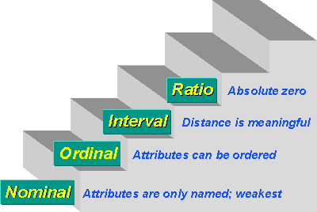
Figure 6 : Measurement Scale Hierarchy: Nominal, Ordinal, Interval, and Ratio
Scale awareness prevents misuse of statistical techniques.

Interval and Ratio Scales
Interval scales possess equal intervals but lack absolute zero. Ratio scales include both equal intervals and true zero.
Most computational performance metrics—such as latency, memory consumption, throughput, and error rates—are ratio-scale measurements. Ratio scales permit full mathematical operations and parametric statistical testing.
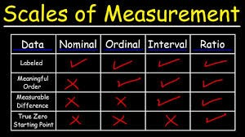
Figure 7 : Statistical Operations Permitted Across Different Measurement Scales
Proper identification of measurement scale ensures analytical correctness.

Principles of Instrument Construction
Instrument design operationalizes measurement into structured data collection mechanisms. In IT research, instruments may include benchmarking tools, logging systems, monitoring dashboards, survey questionnaires, or simulation scripts.
Instrument design requires alignment with conceptual definitions and research design. Instrument design errors propagate directly into data distortion

Figure 8 : Principles of effective instrument design
Instrument construction must ensure clarity, neutrality, precision, and alignment with operational definitions.
For computational instruments, this includes:
• Defining benchmarking parameters
• Standardizing workload conditions
• Ensuring consistent data logging intervals
For survey instruments, question phrasing must avoid bias and ambiguity..

Pretesting, Pilot Testing, and Validation
It is necessary to ensure that research instruments produce accurate, reliable, and meaningful data before full-scale implementation. Pretesting, pilot testing, and validation are used to achieve it. Without these steps, unnoticed design flaws—such as unclear survey questions, unstable benchmarking scripts, or inconsistent logging mechanisms—can lead to systematic measurement errors and invalid conclusions.
Pretesting evaluates whether research instruments function as intended before full-scale data collection begins. It involves administering the instrument under realistic but controlled conditions to identify technical or structural weaknesses. In IT research, pretesting may reveal issues such as inconsistent logging intervals, inaccurate latency measurements, unstable benchmarking scripts, unclear survey instructions, or missing data fields.
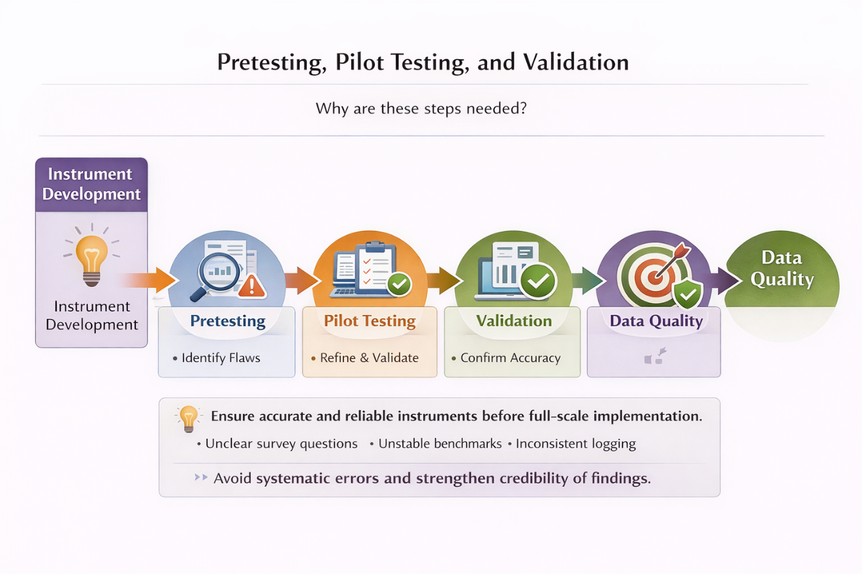
Figure 9 : Testing and validation process in IT research
Pilot testing extends pretesting by implementing the instrument with a small sample that closely resembles the actual study population or system environment. For example, a pilot test of a system monitoring tool may detect performance fluctuations caused by background processes. Similarly, pilot surveys may reveal ambiguous wording or misunderstood questions. Identifying such issues early prevents large-scale data distortion.
Validation procedures confirm that instruments accurately measure the intended constructs. This may involve comparing results with established benchmarks, using alternative measurement tools (cross-validation), or verifying consistency across different environments. Refinement after pilot testing strengthens reliability and validity, ensuring higher data quality before full deployment.

Ethical and Technical Integrity in Instrument Design
Instrument design must uphold both ethical responsibility and technical consistency. Ethical safeguards include data anonymization, informed consent (for survey participants), restricted access controls, and secure storage mechanisms. In IT research involving system logs or user data, encryption and controlled database access are essential to protect privacy and prevent misuse.
Technical integrity ensures that instruments operate consistently across platforms and do not introduce unintended bias. For example, benchmarking tools must produce consistent outputs regardless of operating system variations. Logging systems must timestamp data accurately and maintain synchronization across distributed components.
Failure to maintain ethical and technical integrity compromises research credibility. Poor security practices can expose sensitive data, while inconsistent software behavior can distort measurements. Therefore, instrument integrity is foundational to trustworthy and defensible empirical findings.

Discussion : Research Design and Measurement

Choose at least one of the following questions and post your opinion about it on the discussion board under “Chapter 4: Research Design and Measurement”. Alternatively, you can also add a response to one of the posts made by your classmates.

  - Why is research design considered a “blueprint” for a study?
  - Why is defining the population clearly important before sampling?
  - When is non-probability sampling acceptable in IT research?
  - Can a measurement be reliable but not valid? Give an example.
  - What problems occur if the wrong measurement scale is used?
  - Why are pilot testing and validation important before large-scale data collection?
  - How can poor instrument design distort research findings?
You can click

Evaluating Research Quality

Level 2 headings may be created by course providers in the future.

Evaluating Research Quality
Select a published IT study (journal article, conference paper, or credible technical report) and answer each of the following questions. The answers to each question should be provided only in the designated space just below the questions.

  - What is the title of the article/paper you chose?
  - What type of research design was used?
  - Was the sampling method clearly defined?
  - How were variables measured? Were validity and reliability discussed?
  - What improvements would you suggest?

Chapter Overview

Level 2 headings may be created by course providers in the future.
Data analysis in Information Technology is the discipline of transforming raw observations into structured conclusions through statistical reasoning and systematic interpretation. In this chapter, students explore descriptive statistics, hypothesis testing, correlation, regression, and methods for interpreting both statistical and practical significance. Emphasis is placed on clarity in presentation, accurate reporting of findings, and effective communication in written and oral formats. This framing matters because analytical rigor and transparent presentation determine whether research findings contribute meaningfully to scholarly and professional discourse.
By the end of this chapter, students will be able to:

  - Apply descriptive statistics and exploratory data analysis.
  - Perform hypothesis testing and interpret statistical and practical significance.
  - Use correlation and regression for association and prediction.
  - Write and present findings in written and oral formats.

Conceptual Role of Descriptive Analysis

Data presentation represents the first analytical transformation of collected observations. Raw datasets, whether numerical logs, survey responses, or system performance metrics, are not immediately interpretable. They must be organized, summarized, and structured before inferential reasoning can occur.
Descriptive analysis serves three primary analytical purposes: summarization, structure detection, and preparation for inference. Descriptive analysis does not attempt to test hypotheses; rather, it clarifies the structural characteristics of the dataset and prepares it for deeper evaluation.
Summarization reduces complex datasets into interpretable indicators. Measures of central tendency, such as the mean and median, identify typical performance levels. Measures of dispersion, including standard deviation and interquartile range, reveal stability or volatility within the system.
For example, in evaluating distributed caching performance, the mean response time provides baseline latency under specific conditions. However, if the standard deviation is high, the system may exhibit instability even if the average appears acceptable. A stable system requires both low mean latency and low variability.
Descriptive analysis also detects distributional characteristics. Skewness may indicate occasional system overload events. Kurtosis may suggest heavy-tailed latency distributions, indicating rare but extreme response delays.
These structural characteristics influence subsequent inferential decisions. For example, strongly skewed distributions may violate assumptions of parametric statistical tests, requiring non-parametric alternatives. Descriptive statistics therefore function as analytical diagnostics.

Distributional Structure and Visualization

Distributional Structure
Understanding distribution shape is essential in performance-based IT research. Histograms reveal whether latency measurements cluster symmetrically or whether long-tail delays occur. Box plots identify median values and highlight outliers that may reflect network congestion or system instability.
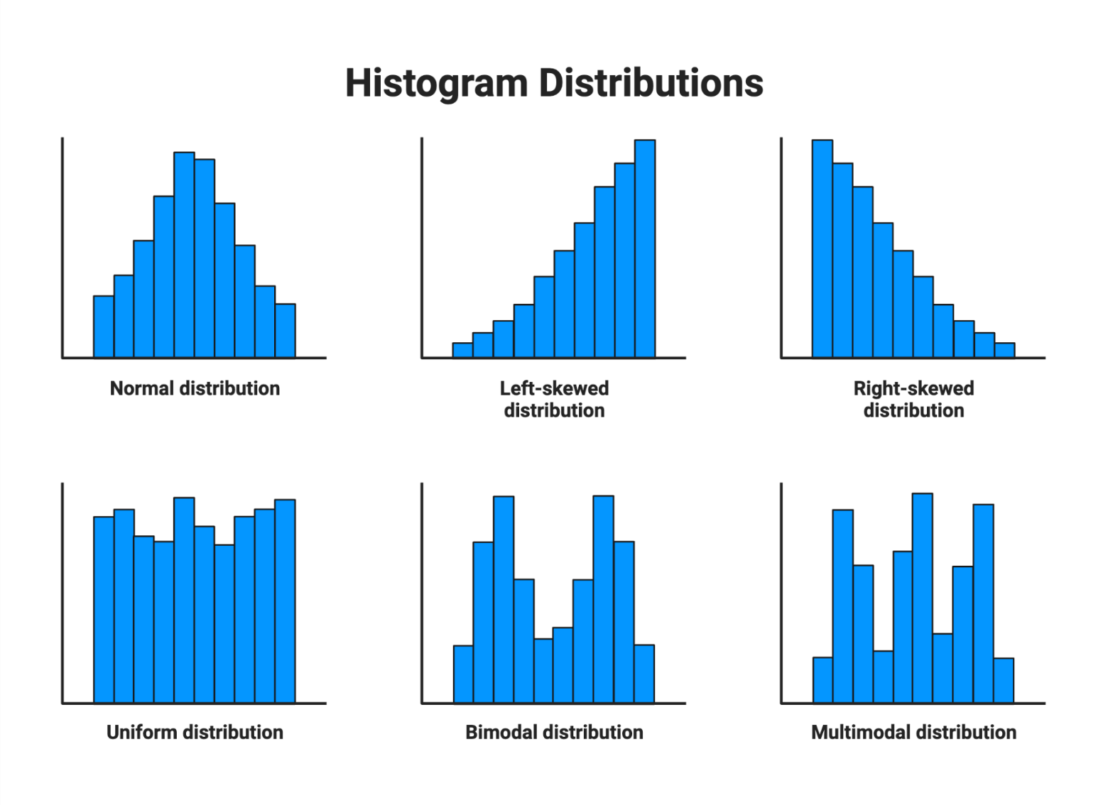
Figure 1 : An Example Histogram Representation of Latency Distribution
Graphical representation serves interpretive rather than decorative purpose. Poor visualization may distort findings through misleading axis scaling or inappropriate aggregation.
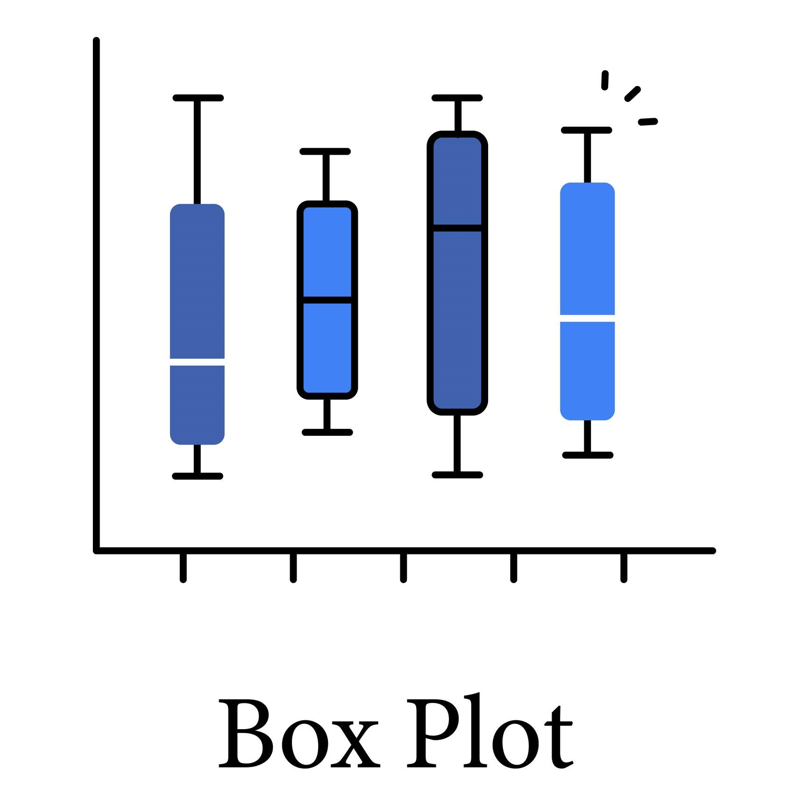
Figure 2 : An Example Box Plot Illustrating Median, Dispersion, and Outliers
For instance, aggregating latency data across heterogeneous concurrency conditions may conceal performance degradation under peak load. Disaggregated presentation reveals contextual variation. Visualization must therefore align with research objectives and variable structure.

Descriptive Analysis as Foundation for Inferential Testing
Inferential procedures rely on assumptions about distribution, independence, and variance structure. Descriptive analysis verifies whether these assumptions hold.
If response times demonstrate heavy skewness, transformation procedures such as logarithmic scaling may be necessary before regression analysis. If variability differs across experimental conditions, heteroscedasticity adjustments may be required.
Descriptive statistics therefore perform a methodological gatekeeping function. They prevent inappropriate statistical modeling and enhance inferential credibility

Exploratory Data Analysis as Diagnostic Methodology

Exploratory analysis precedes formal statistical testing and serves as a diagnostic stage in the research process. It aims to understand structural properties of the dataset, detect anomalies, and evaluate distributional characteristics before inferential modeling is conducted. Exploratory examination reduces the risk of model misspecification and incorrect statistical conclusions.
Exploratory Data Analysis (EDA) involves systematic inspection of data distributions, variability patterns, and preliminary relationships. It does not begin with hypothesis confirmation; instead, it seeks to understand how the data behave.
EDA examines:
• Distribution symmetry
• Variance patterns
• Temporal fluctuations
• Clustering tendencies
• Possible non-linear relationships
In distributed systems research, exploratory analysis may reveal that latency increases sharply beyond a concurrency threshold rather than increasing linearly. Such discovery informs model selection, indicating that linear regression may be insufficient and that polynomial or segmented models may be required.
Exploratory procedures also evaluate independence assumptions. For example, sequential system logs may exhibit autocorrelation, particularly in time-series datasets. If latency values are correlated across time intervals, independence assumptions required for many statistical tests are violated.
EDA therefore functions as methodological calibration.

Outlier Detection and Pattern Exploration

Outlier Detection and Interpretation
Outliers represent observations that deviate substantially from overall distribution patterns. In IT systems, extreme latency spikes may reflect transient hardware failure, sudden traffic surges, or measurement inaccuracies.
Outlier detection techniques include interquartile range analysis, standardized residual examination, and robust statistical measures. However, removal of outliers requires careful justification. Arbitrary exclusion may conceal meaningful system vulnerabilities.
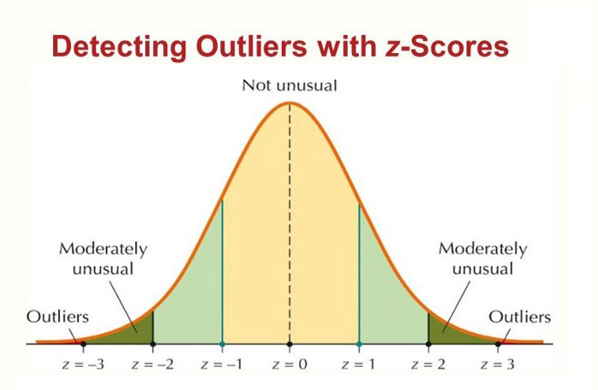
Figure 3 : Standardized Residual Plot for Identifying Anomalous Observations
Outliers may indicate structural weaknesses requiring further investigation. For example, repeated extreme latency events under specific load patterns may signal scalability limitations rather than measurement error.
Distinguishing between noise and meaningful anomaly requires contextual evaluation.

Temporal and Multivariate Pattern Exploration
Complex IT systems often produce multivariate datasets. Latency may interact with memory consumption, CPU utilization, and network bandwidth simultaneously.
Exploratory visualization such as scatterplot matrices, heat maps, and time-series graphs reveal interaction effects and temporal trends.
Trend analysis may uncover systematic degradation over prolonged system usage. Seasonality patterns may reveal daily usage cycles in institutional networks.
Exploratory pattern detection strengthens hypothesis formulation and model refinement.

Hypothesis Testing

Logical Structure of Statistical Inference
Hypothesis testing represents the formal mechanism through which empirical evidence is evaluated against theoretical expectations. It transforms observed differences or associations into structured statistical inference. Without systematic hypothesis testing, research findings remain descriptive rather than explanatory.
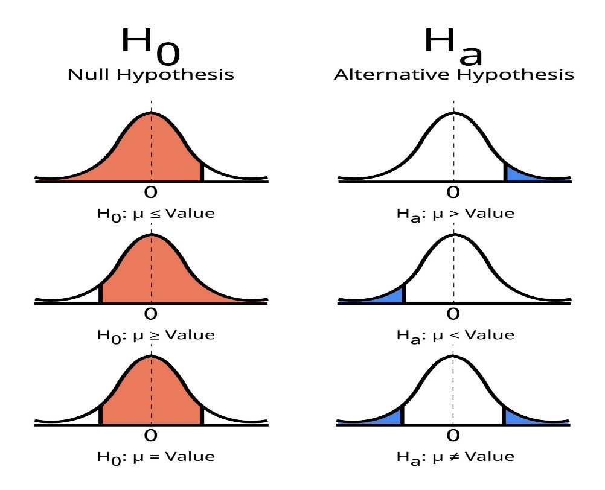
Figure 4 : Structure of Null and Alternative Hypothesis Framework
Statistical inference operates within probabilistic reasoning. The null hypothesis (H₀) assumes no effect or no relationship. The alternative hypothesis (H₁) asserts the presence of effect.
The testing procedure evaluates whether observed data are sufficiently inconsistent with the null hypothesis to justify rejection.
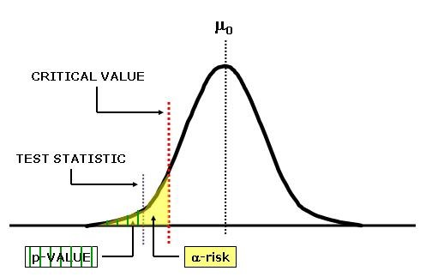
Figure 5 : Decision Rule and Rejection Region in Hypothesis Testing
This framework ensures that conclusions are based on probability rather than intuition.
For example, when testing whether caching reduces average latency, the null hypothesis states that no difference exists between caching and non-caching conditions. The alternative asserts measurable reduction.
Statistical tests quantify whether observed differences exceed what random variability would reasonably produce.

Hypothesis Testing For Population Proportions Using A Z Test, Rejection Regions And Critical Values

Significance Levels, Power, and Error Risks

The significance level (α) defines the threshold for rejecting the null hypothesis. Common thresholds include 0.05 or 0.01. Lower α reduces probability of Type I error but increases risk of Type II error.
Type I error occurs when a true null hypothesis is rejected. In system performance research, this may mean concluding that caching improves performance when observed difference is due to random fluctuation.
Type II error occurs when a false null hypothesis is retained. This may result from insufficient sample size or excessive measurement variability.
Statistical power represents the probability of detecting real effects. In performance benchmarking, increasing number of experimental runs enhances power and reduces error risk.
Balancing error probabilities requires deliberate planning

Assumptions and Model Appropriateness

Hypothesis tests rely on assumptions regarding distribution shape, independence, and variance homogeneity. Violation of these assumptions undermines validity.
For example, t-tests assume approximately normal distribution of residuals. If latency data exhibit heavy skewness, parametric testing may produce misleading p-values.
Non-parametric alternatives such as Mann–Whitney U test may be appropriate when assumptions are violated.
Model appropriateness must therefore be evaluated before inference.

Correlation and Regression Analysis

Correlation Analysis
Correlation coefficients measure direction and strength of linear association. Pearson’s correlation coefficient applies to interval and ratio variables under normality assumptions. Spearman’s rank correlation applies to ordinal data or non-normal distributions.
A positive coefficient indicates that variables increase together. A negative coefficient indicates inverse movement.
Correlation magnitude interpretation requires caution. A moderate correlation may reflect underlying confounding factors. For example, increased concurrency and increased latency may both result from peak usage periods rather than direct causal relationship.
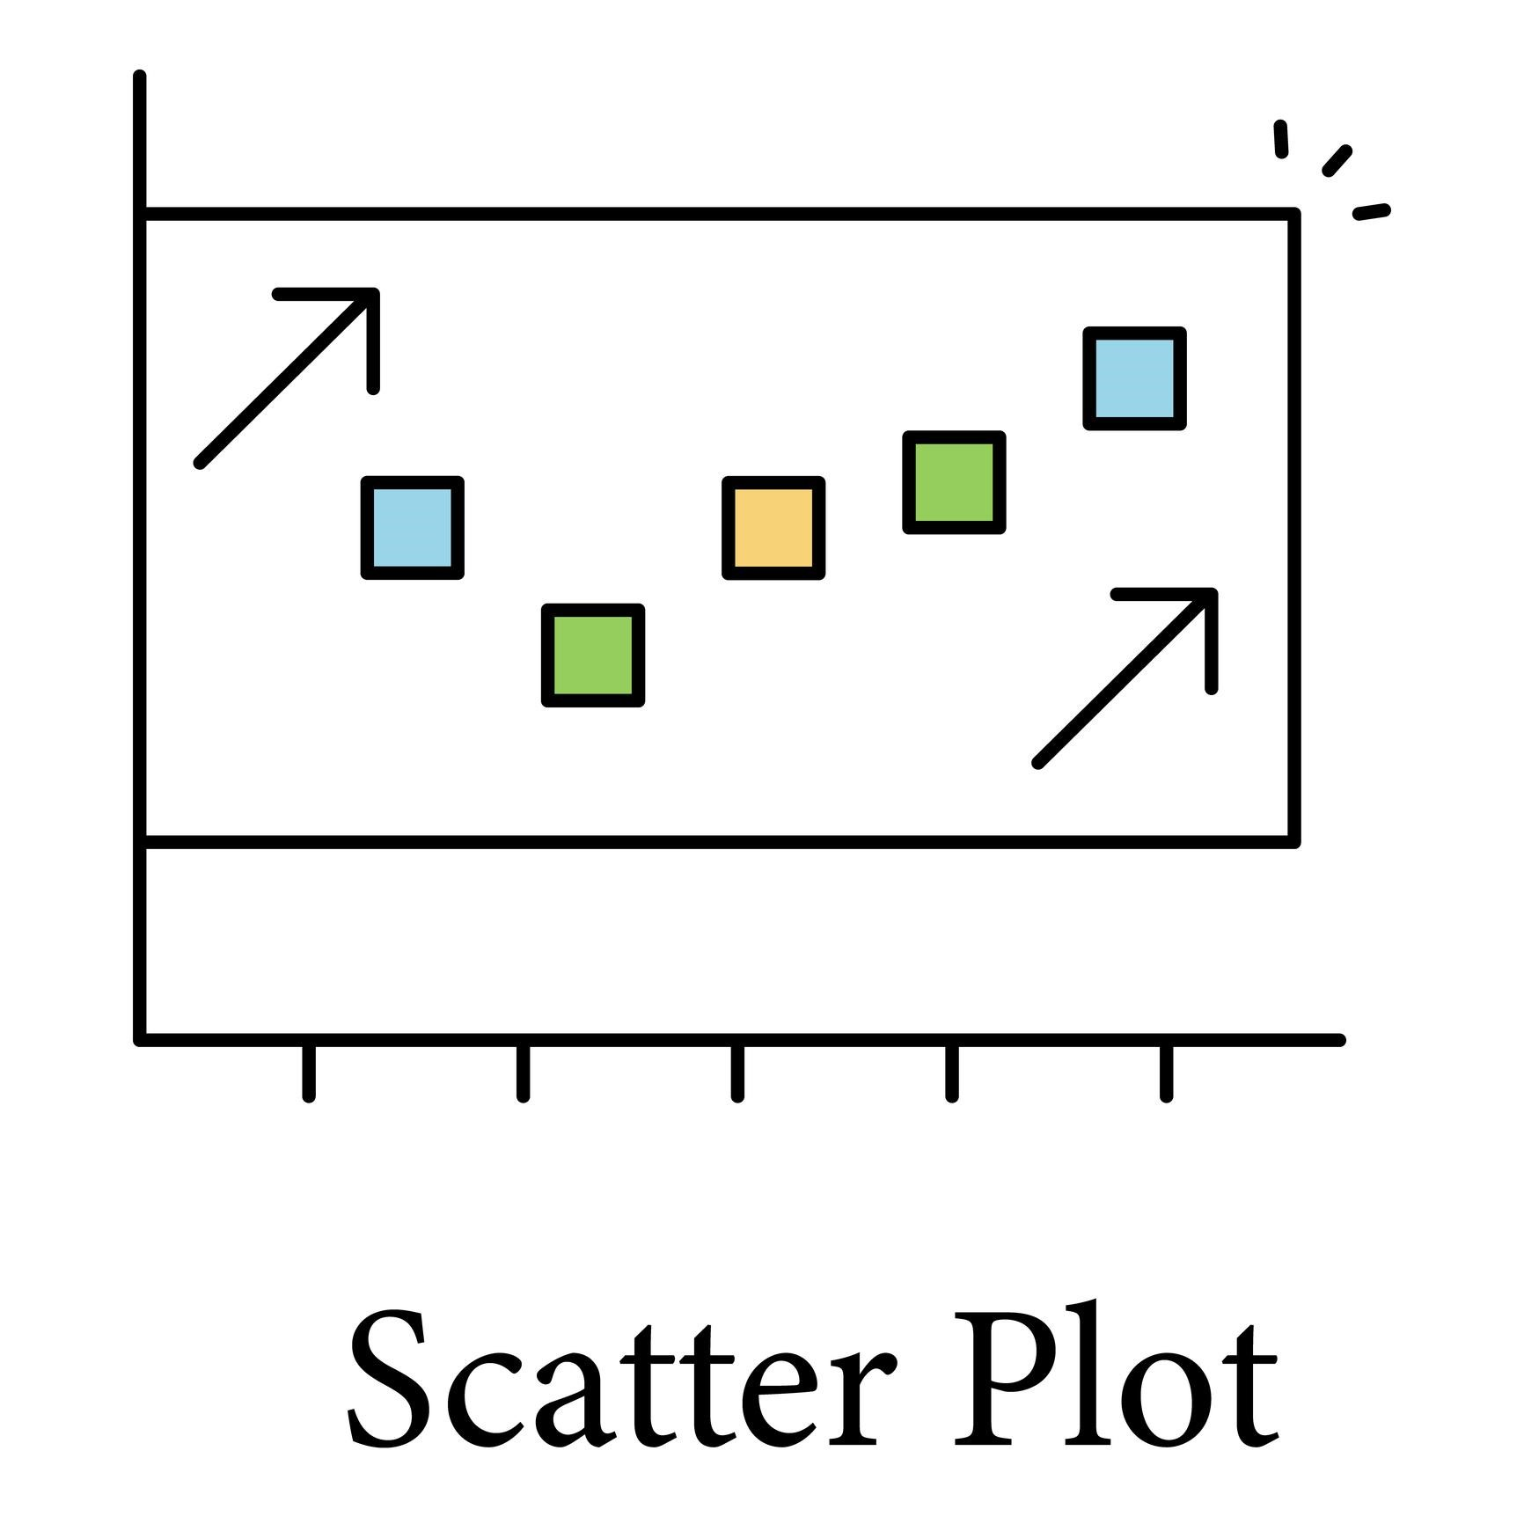
Figure 6 : Positive Linear Correlation Between Concurrency and Latency
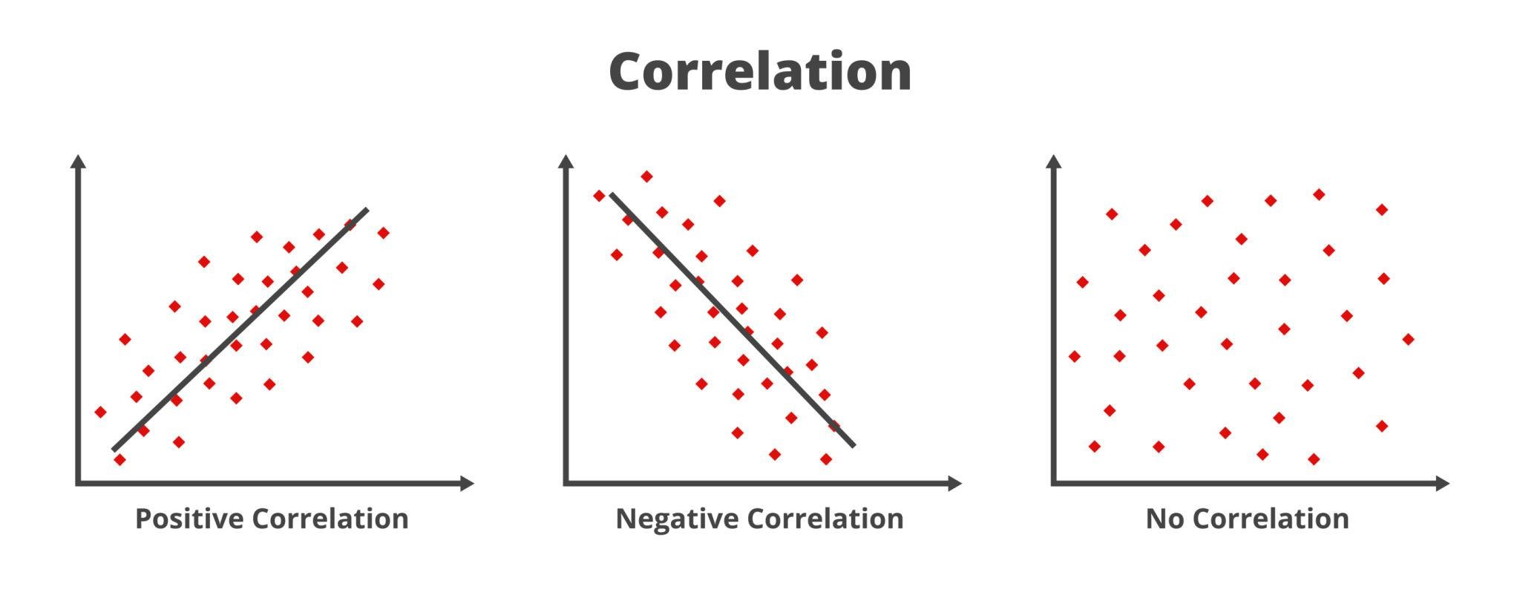
Figure 7 : Correlation Pattern Illustrations
Interpretation must account for context and potential third-variable influence.

Regression Modeling and Predictive Analysis
Regression analysis extends correlation by modeling predictive relationships. In IT contexts, regression may estimate how changes in concurrency predict latency variation.
Simple linear regression models one independent variable. Multiple regression incorporates several predictors, such as concurrency, memory utilization, and caching strategy.
Model evaluation includes examining residual plots, coefficient significance, and overall model fit.
Regression assumptions include linearity, independence, homoscedasticity, and normality of residuals. Violations reduce interpretive reliability.
Predictive modeling enables performance forecasting and system optimization planning.

Structural Architecture of a Research Report

Report writing is not merely documentation; it is the formal structuring of knowledge. Analytical rigor achieves its full value only when findings are communicated with clarity, logical coherence, and methodological transparency. The research report functions as a permanent scholarly record that allows independent evaluation, replication, and extension.
A research report follows a logical architecture designed to guide readers from problem identification to conclusion. The structure is not arbitrary; it reflects the epistemological flow of scientific reasoning.
The major structural components include:

    - Introduction
    - Literature Review
    - Methodology
    - Results
    - Discussion
    - Conclusion
    - References
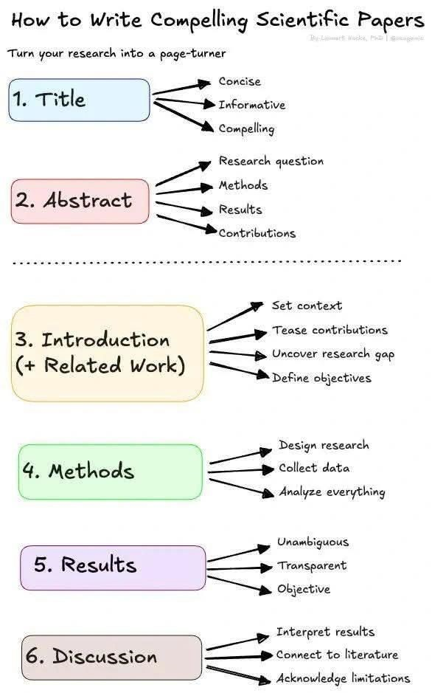
Figure 8 : Standard IMRD Structure of a Research Report
The Introduction defines the problem and research objectives. The Literature Review situates the study within existing scholarship. The Methodology section details research design, sampling, measurement, and analytical procedures. The Results section presents findings objectively without interpretive commentary. The Discussion section interprets findings in relation to theoretical expectations and prior studies. The Conclusion synthesizes implications and outlines limitations.
Logical separation between sections preserves analytical clarity. Blurring results and discussion reduces interpretive discipline. Moreover, without detailed description of experimental configuration, workload simulation parameters, or regression model specifications, replication becomes impossible.

Analytical Precision and Argument Development

Level 2 headings may be created by course providers in the future.

Argument Development
Effective report writing requires systematic argument development. Findings must be linked explicitly to research questions and hypotheses.
For example, if the research investigates whether distributed caching reduces average response latency under high concurrency, the Results section should present:

    - Mean latency under control condition
    - Mean latency under experimental condition
    - Statistical test results
    - Effect size
The Discussion section must then interpret whether the observed reduction is statistically significant, practically meaningful, and consistent with theoretical predictions.
Analytical precision also requires cautious language. Terms such as “improves,” “causes,” or “proves” must be used only when design and evidence justify such inference. Overstatement undermines credibility.
Report writing therefore functions as structured reasoning rather than narrative storytelling.

Transparency, Replicability, and Ethical Reporting
Scientific reporting requires transparency. All methodological decisions, exclusion criteria, transformations, and assumptions must be documented.
For example, if extreme latency values were removed due to confirmed measurement error, the criteria and justification must be described. Omission of such details compromises interpretive integrity.
Ethical reporting also includes accurate citation, acknowledgment of limitations, and avoidance of selective result presentation.
Transparent documentation strengthens the reliability of scholarly contribution.

Presenting Insights and Findings

Level 2 headings may be created by course providers in the future.

Interpretation Beyond Statistical Output
Presenting insights extends beyond reporting numerical results. It requires translating statistical outputs into meaningful interpretation aligned with theoretical and practical contexts. Insight presentation bridges quantitative evidence and conceptual understanding.
Statistical software produces coefficients, p-values, and confidence intervals. However, these outputs acquire meaning only through contextual interpretation.
For example, regression output may indicate that each additional 100 concurrent users increases latency by 15 milliseconds. Interpretation must evaluate whether this increase is operationally acceptable within system performance standards.
Interpretation should proceed through structured reasoning:

  - Identify statistical result.
  - Assess magnitude of effect.
  - Compare with theoretical expectations.
  - Evaluate contextual relevance.
  - Identify implications.
This structured interpretive process prevents superficial conclusion drawing.

Integrating Findings with Theory and Literature
Insights must be situated within prior scholarship. If observed latency reduction aligns with enterprise-scale caching studies but diverges under limited bandwidth environments, contextual explanation is required.
Integration strengthens scholarly contribution by clarifying whether findings confirm, refine, or challenge existing theory.
Unexpected findings must not be dismissed. Instead, they should be analyzed for potential methodological, contextual, or theoretical explanations.
Interpretive depth transforms data into knowledge.

Visual Communication of Insights
Effective visual presentation enhances cognitive processing. However, visualization must adhere to accuracy and proportional representation.
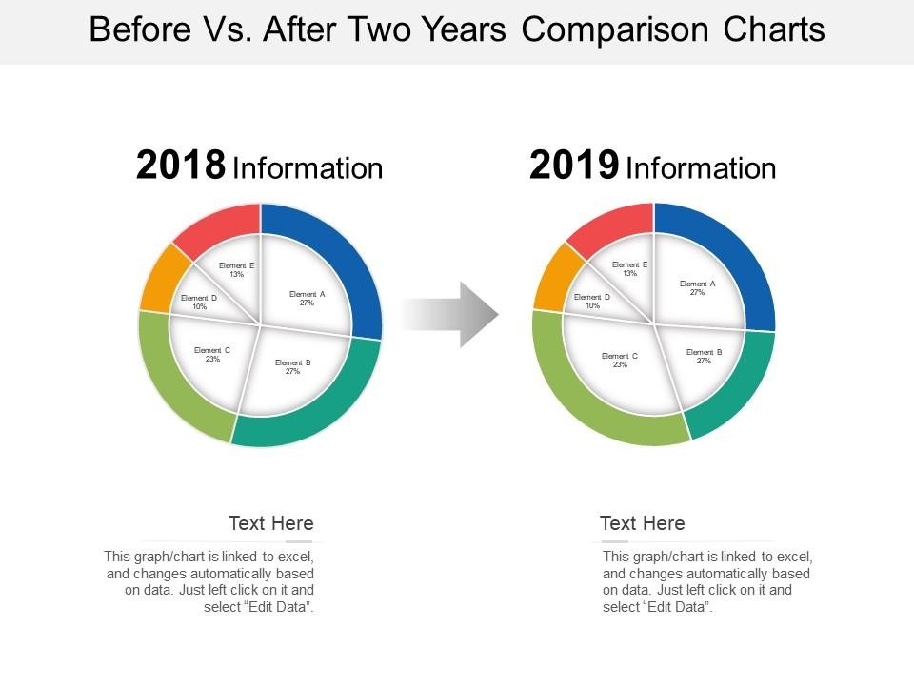
Figure 9 : Comparative Graph with Consistent Axis Scaling
Comparative graphs must use consistent axes. Time-series trends must clearly indicate scale intervals. Regression plots must display residual distribution where appropriate. Visualization must serve analytical clarity rather than aesthetic complexity.

Written and Oral Reports

Level 2 headings may be created by course providers in the future.

Written Academic Reporting Standards
Communication of research occurs in written and oral formats, each requiring distinct structural considerations while maintaining analytical integrity.
Written academic reporting demands:

  - Logical sequencing
  - Formal tone
  - Accurate citation
  - Clear methodological description
  - Structured visual integration
Tables and figures must be numbered, titled, and referenced within text. Interpretation must accompany presentation rather than leaving readers to infer meaning independently.
Consistency in terminology ensures conceptual coherence throughout the document.
Written reporting must balance technical precision with readability.

Oral Presentation and Knowledge Dissemination
Oral presentation requires condensation of complex analysis into structured narrative suitable for limited time frames.
An effective oral presentation typically follows this structure:

  - Problem statement
  - Research objective
  - Methodological overview
  - Key findings
  - Implications
  - Conclusion

Figure 10 : Structured Framework for Oral Research Presentation
Slides must emphasize key findings rather than replicate full report text. Visual clarity, controlled pacing, and structured explanation enhance comprehension.
Audience engagement requires clarity of speech, logical progression, and effective response to questions.

Discussion : Analysis and Presentation of Data

Choose at least one of the following questions and post your opinion about it on the discussion board under “Chapter 5: Analysis and Presentation of Data”. Alternatively, you can also add a response to one of the posts made by your classmates.
- Why is descriptive analysis important before hypothesis testing?
Before running statistical tests, researchers examine means, medians, standard deviation, and graphs.

        - What problems might occur if hypothesis testing is performed without first exploring the data?
        - Can you think of an IT example where skipping descriptive analysis could lead to incorrect conclusions?
- Correlation Does Not Mean Causation
Correlation measures association between variables.

        - Why does correlation not automatically prove cause and effect?
        - Can you give an example from IT (e.g., concurrency and latency, AI usage and grades) where a third variable might explain the relationship?
- Why Is Clear Presentation of Findings Important?
Research findings must be presented clearly in written and oral formats.

        - How can poor graphs or unclear reporting mislead readers?
        - Do you think it is really important to separate Results and Discussion sections in a research report? Why?

Chapter Overview
Current research in Information Technology is the discipline of investigating emerging computational paradigms and addressing evolving technological challenges. In this chapter, students examine contemporary research domains including artificial intelligence and machine learning, cybersecurity, cloud and distributed systems, big data analytics, and the Internet of Things. The chapter highlights methodological complexities, interdisciplinary integration, scalability concerns, and open research questions across domains. This framing matters because understanding current research directions prepares students to engage with cutting-edge innovation and identify opportunities for scholarly contribution.
By the end of this chapter, students will be able to:

  - Explain research directions in AI/ML, cybersecurity, cloud/distributed systems, big data, and IoT.
  - Discuss methodological challenges and emerging research questions across domains.

Theoretical Foundations of Machine Learning

Artificial Intelligence (AI) research investigates computational systems capable of perception, reasoning, adaptation, and decision-making. Contemporary AI research spans theoretical model development, large-scale system engineering, and governance frameworks designed to ensure safe and responsible deployment. Machine Learning (ML) research focuses on data-driven modeling techniques that enable predictive and adaptive system behavior.
Machine Learning research is grounded in statistical learning theory, optimization theory, probability, and computational complexity analysis. At its core, ML seeks to approximate unknown functions that map inputs to outputs based on observed data. The theoretical objective is to design models that generalize effectively beyond training data while maintaining computational efficiency.
Supervised learning investigates model training using labeled datasets. Research in this area focuses on minimizing empirical risk while controlling model complexity to prevent overfitting. Techniques such as regularization, cross-validation, and ensemble learning are studied to improve robustness. A major research challenge concerns generalization bounds: determining how accurately a model trained on finite data will perform on unseen examples.
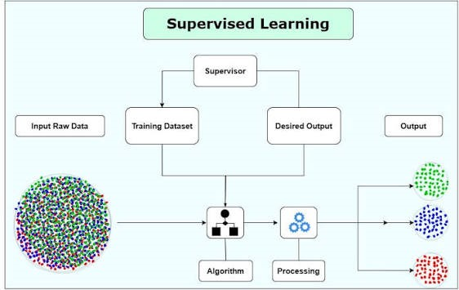
Figure 1 : Supervised Learning Paradigm Overview
Unsupervised learning examines pattern discovery without labeled outcomes. Clustering algorithms, dimensionality reduction methods such as Principal Component Analysis, and manifold learning approaches are central research areas. Stability of clusters under perturbation and scalability to high-dimensional data remain active topics of investigation.
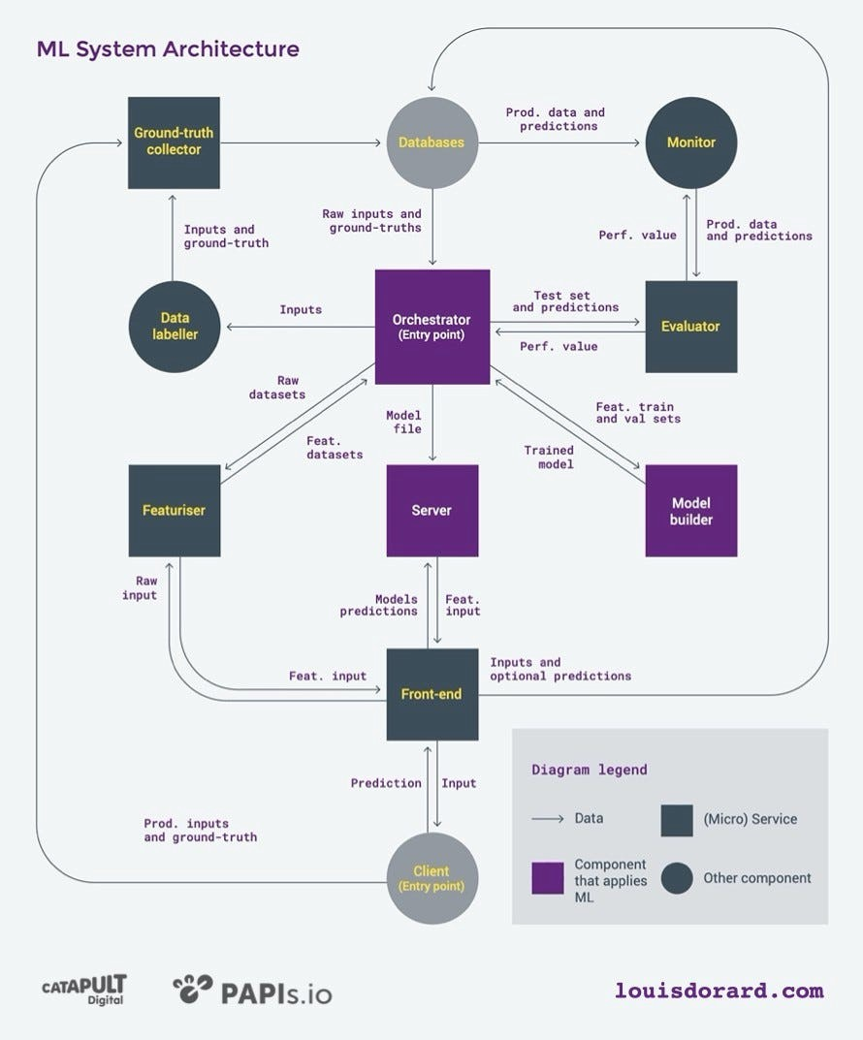
Figure 2 : Unsupervised Learning Paradigm Overview
Reinforcement learning studies sequential decision-making under uncertainty. Agents learn optimal policies through interaction with dynamic environments. Research challenges include reward design, exploration–exploitation balance, and convergence guarantees in large state spaces. Deep reinforcement learning introduces additional complexity due to instability and high computational cost.

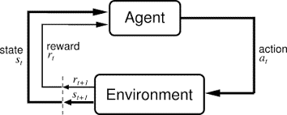
Figure 3 : Reinforcement Learning Paradigm Overview
Emerging research questions include improving interpretability, reducing energy consumption of large-scale models, and systematically evaluating fairness and bias within predictive systems

Generative AI and Large-Scale Models

Generative AI and Large-Scale Models
Generative AI research has been transformed by transformer-based architectures capable of modeling long-range dependencies in sequential data. Large-scale language and multimodal models are trained on massive datasets using distributed computing infrastructures. Research investigates scaling laws that relate model size, data volume, and performance improvements.
A critical research problem concerns hallucination reduction — minimizing instances where generative systems produce plausible but factually incorrect outputs. Robustness against adversarial prompting is another area of concern, as models may be manipulated into generating unsafe or misleading content.
Multimodal integration combines text, image, audio, and video data into unified learning frameworks. Research evaluates representation alignment and cross-modal reasoning mechanisms. Computational sustainability has emerged as a parallel concern, given the enormous energy consumption associated with training large models.
Methodologically, generative AI research relies on benchmark evaluation frameworks, ablation studies, large-scale experimentation, and human feedback optimization. Alignment research investigates how model objectives can be harmonized with societal values and regulatory expectations.
Responsible AI and Governance
Responsible AI research integrates fairness metrics, bias detection methodologies, explainability models, and regulatory compliance frameworks. Explainable AI investigates techniques such as SHAP values, attention visualization, and surrogate modeling to increase transparency.
Algorithm auditing research examines mechanisms for detecting discriminatory outcomes and performance degradation across demographic groups. Governance research explores accountability structures, documentation standards, and lifecycle monitoring protocols.
AI research increasingly intersects with legal and policy domains. Compliance with emerging regulatory frameworks requires interdisciplinary collaboration between technologists, legal scholars, and policymakers. Ethical risk assessment is becoming an integral component of system design.

Intrusion Detection and Intelligent Threat Monitoring
Cybersecurity research addresses the protection of digital infrastructure against unauthorized access, system manipulation, and service disruption. The threat landscape is dynamic and adversarial, requiring adaptive and predictive defense mechanisms. Modern research integrates cryptography, machine learning, network science, and behavioral analytics.
Intrusion detection research focuses on identifying malicious activity within networks or systems. Signature-based detection relies on known attack patterns, but its inability to detect zero-day exploits limits effectiveness.
Anomaly-based detection systems model normal network behavior and identify deviations. Machine learning methods classify traffic patterns and detect suspicious activity. Supervised models require labeled datasets, while unsupervised approaches detect structural irregularities without predefined categories.
Reducing false positives remains a significant challenge. High alert volumes may overwhelm administrators and reduce operational efficiency. Encrypted traffic further complicates detection because payload inspection becomes restricted. Research investigates metadata analysis and encrypted traffic fingerprinting techniques.
Real-time scalability is another critical issue, particularly in high-throughput enterprise networks. Distributed detection architectures and hardware acceleration techniques are explored to maintain performance without sacrificing detection accuracy.

Cryptography and Post-Quantum Security
Cryptographic research underpins secure communication and data protection. Traditional algorithms such as RSA and ECC rely on mathematical problems that may become vulnerable with the advent of quantum computing.

Figure 4 : Classical Cryptography
Post-quantum cryptography investigates lattice-based, code-based, and hash-based schemes designed to resist quantum attacks. Research evaluates mathematical hardness assumptions, key size trade-offs, and computational overhead.
Homomorphic encryption enables computation on encrypted data without decryption, expanding possibilities for secure cloud analytics. Secure multi-party computation allows collaborative data processing without exposing raw data. These techniques support privacy-preserving analytics in healthcare and finance.

Figure 5 : Homomorphic Encryption and Secure Multi-Party Computation Workflow
Balancing computational efficiency with security strength remains central. Implementation challenges include latency overhead, memory consumption, and hardware compatibility.

Cyber Risk Modeling and Resilience Engineering
Cybersecurity research increasingly emphasizes resilience — the ability of systems to maintain functionality during and after attacks. Risk modeling integrates probability theory and attack simulation frameworks to evaluate vulnerability propagation.
Threat modeling maps potential attack surfaces and privilege escalation pathways. Simulation-based research evaluates cascading failure scenarios in distributed systems. Behavioral research examines human factors such as phishing susceptibility and password management practices.
Resilience engineering integrates redundancy, fault tolerance, and rapid recovery mechanisms. Cybersecurity research thus combines prevention, detection, and recovery into unified defense strategies.

Distributed Architecture and Consensus Mechanisms

Cloud computing and distributed systems research examines how computational resources are organized, coordinated, and scaled across geographically distributed environments. The shift from centralized computing to elastic, on-demand infrastructure has transformed system architecture design. Research in this domain addresses not only performance and scalability but also fault tolerance, cost optimization, consistency management, and sustainability.
Distributed systems must operate under partial failure conditions, unpredictable network latency, and dynamic workloads. Unlike monolithic systems, distributed architectures require coordination protocols to ensure reliability while maintaining performance efficiency.
Distributed systems rely on multiple computational nodes that must agree on shared state. Achieving consensus in unreliable networks is one of the most fundamental problems in distributed computing. Research in this area builds on formal models of distributed agreement, including synchronous and asynchronous systems.
Protocols such as Paxos and Raft ensure that nodes maintain consistent logs despite network failures. These consensus mechanisms address issues such as leader election, log replication, and fault tolerance. Research explores optimizing these protocols to reduce latency and message complexity.
The CAP theorem states that in the presence of a network partition, a distributed system must choose between consistency and availability. This theoretical constraint motivates research into tunable consistency models such as eventual consistency and causal consistency. Researchers evaluate trade-offs using simulation frameworks and stress-testing under varying fault conditions.
Methodologically, distributed systems research often employs:

  - Fault injection testing
  - Network latency simulation
  - Load testing under synthetic traffic
  - Formal verification of protocol correctness
Another research direction involves Byzantine fault tolerance, which considers malicious or arbitrarily failing nodes. Blockchain consensus protocols extend these ideas into decentralized environments.
Current research questions include improving consensus scalability, reducing communication overhead, and integrating AI-driven workload optimization.

Edge Computing and Decentralized Processing
Edge computing redistributes computational resources from centralized cloud data centers to nodes located closer to data sources. This architectural shift reduces latency and network congestion while enabling real-time processing.
Applications such as autonomous vehicles, smart healthcare devices, and augmented reality require millisecond-level responsiveness. Research examines partitioning algorithms that determine which tasks execute at the edge versus in centralized clouds.
Key research challenges include:

  - Synchronization among heterogeneous devices
  - Secure communication across distributed nodes
  - Dynamic resource allocation under mobility conditions
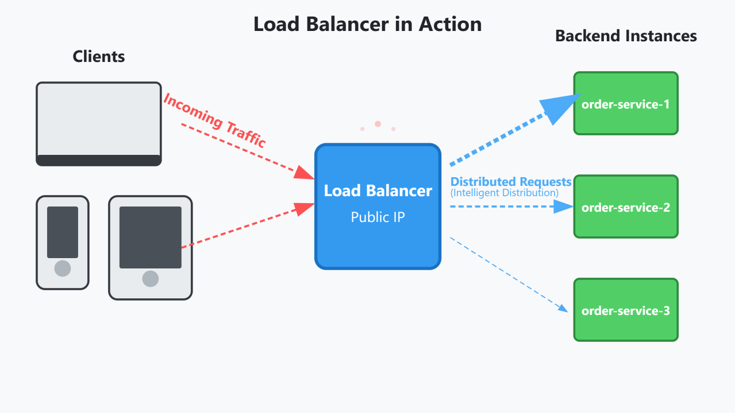
Figure 6 : Edge Computing Architecture: Cloud–Edge–Device Interaction Model
Edge systems often operate under resource constraints. Therefore, lightweight virtualization technologies such as containerization are studied to enable efficient task deployment.
Another research direction investigates federated learning, where models are trained across decentralized devices without centralizing raw data. This approach enhances privacy but introduces communication and coordination complexity.
Methodologically, edge research combines simulation modeling, real-world deployment testing, and latency benchmarking experiments.
Energy-aware scheduling at the edge also intersects with sustainability research, as decentralized nodes may operate on battery-powered or renewable energy systems.

Sustainable and Energy-Efficient Cloud Infrastructure
Data centers consume significant electrical energy due to large-scale computation and cooling requirements. Sustainable cloud research investigates strategies to reduce environmental impact while maintaining performance.
Workload scheduling algorithms optimize task placement to minimize peak energy demand. Research explores carbon-aware scheduling, where computational tasks are shifted to regions with lower carbon intensity energy sources.
Virtualization efficiency improves hardware utilization by consolidating workloads across fewer physical servers. Advanced cooling techniques, such as liquid cooling and dynamic airflow management, are evaluated for thermal efficiency.
Researchers employ computational modeling to estimate carbon footprints and simulate long-term sustainability impact. Life-cycle analysis methods measure total environmental cost from hardware manufacturing to operational use.
Another research area investigates serverless computing, which abstracts infrastructure management and may improve resource utilization efficiency.
Sustainable cloud computing integrates environmental science, electrical engineering, and distributed systems research to achieve balanced performance and ecological responsibility.

Distributed Data Architectures

Data Science research focuses on extracting knowledge from large, complex datasets that exceed the capacity of traditional systems. Big Data environments are often described by the “4Vs”: volume, velocity, variety, and veracity. Addressing these characteristics requires distributed infrastructure capable of storing and processing data across multiple machines simultaneously.
Distributed data systems enable parallel storage and computation through clustered nodes. Frameworks such as Hadoop and Spark implement techniques like MapReduce and in-memory processing to improve scalability and computational efficiency. These systems distribute tasks across nodes to reduce processing time and increase throughput.
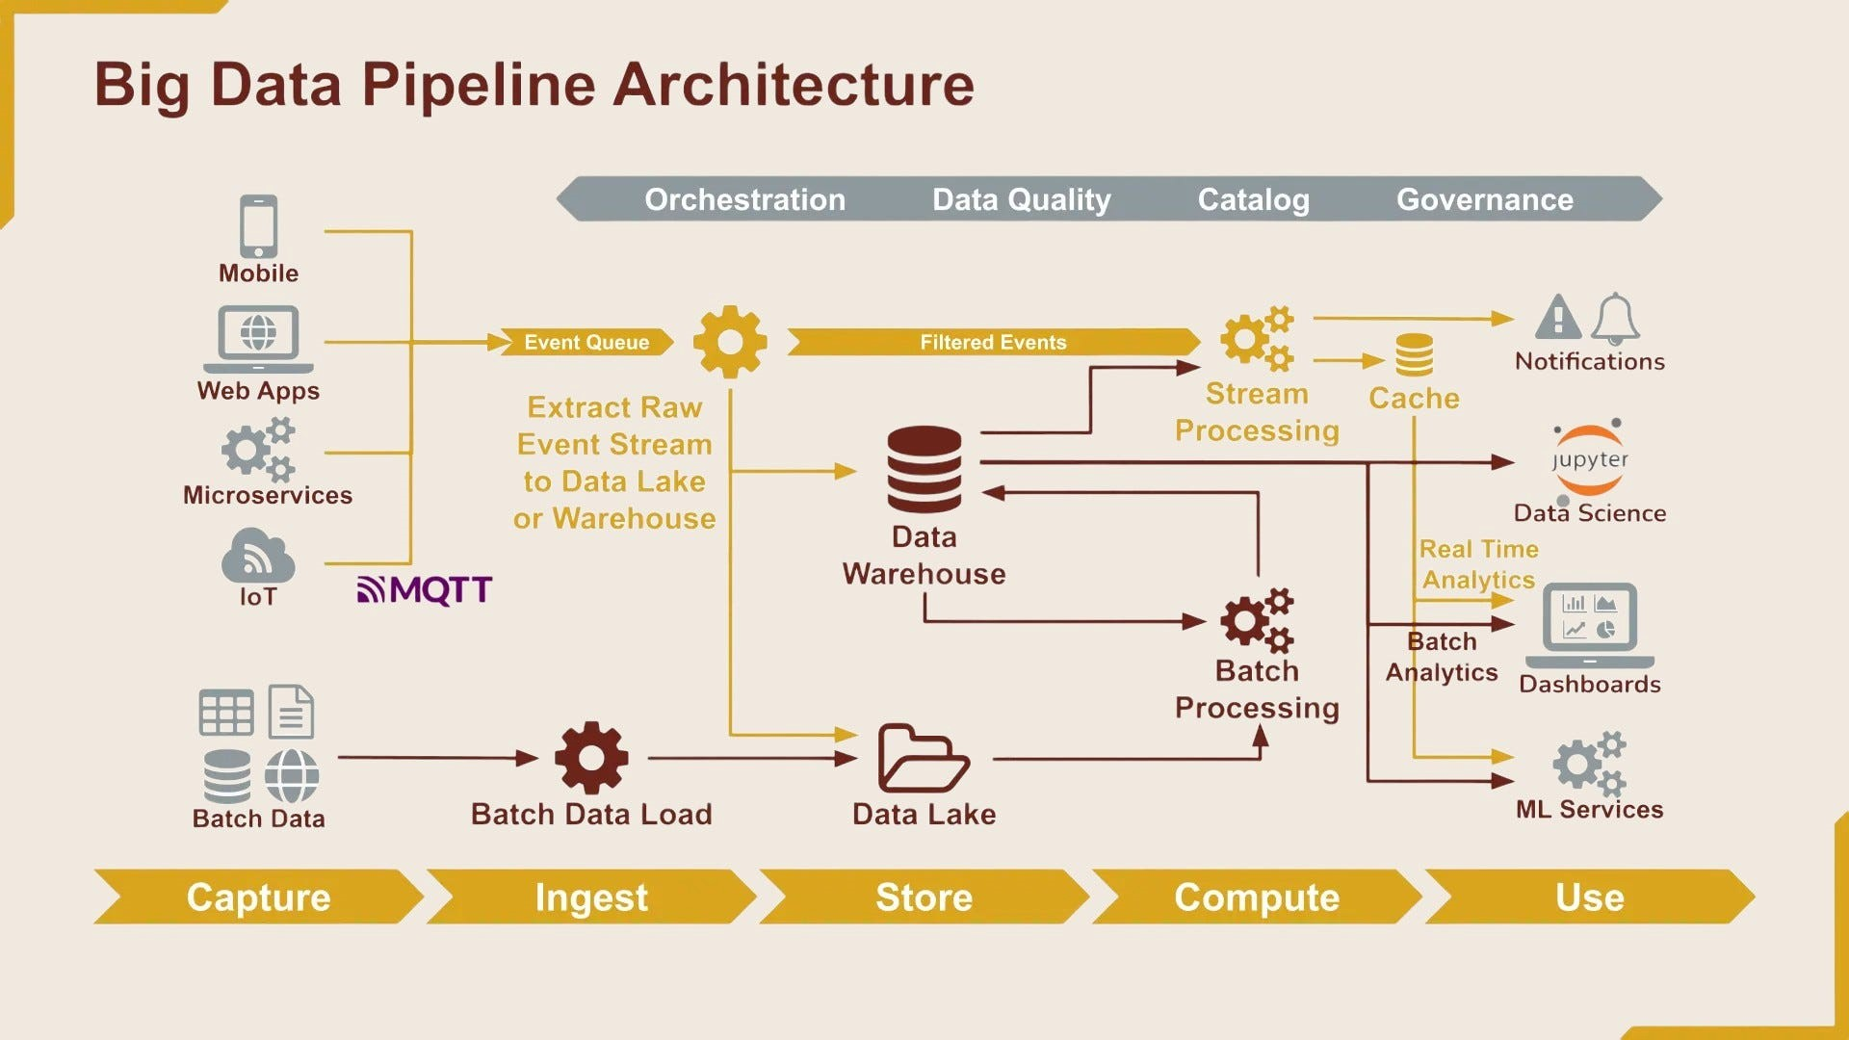
Figure 7 : Distributed Big Data Processing Architecture Using Clustered Nodes
A key research focus within distributed architectures is resource optimization. Task scheduling algorithms determine how computational resources are allocated efficiently, while fault tolerance mechanisms ensure that node failures do not interrupt the entire analytics workflow. Horizontal scaling allows systems to maintain performance as data volume increases.
Data lake architectures further extend distributed infrastructure by centralizing structured and unstructured data in raw form. Researchers compare schema-on-read and schema-on-write models to evaluate trade-offs between flexibility and performance. Benchmarking distributed systems involves performance metrics such as throughput, latency, scalability index, and resource utilization. Experimental evaluation often includes synthetic workload simulation, stress testing with real-world datasets, and horizontal scaling experiments. Ongoing research continues to improve distributed query optimization and memory-efficient data representation.
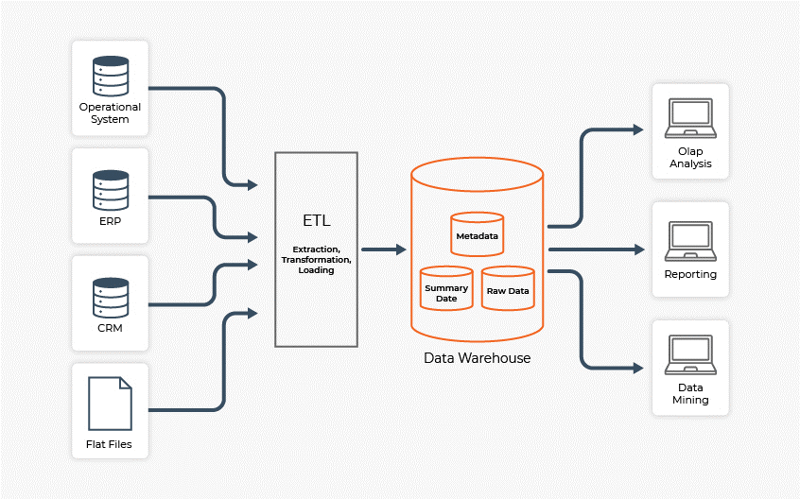
Figure 8 : Big Data Ecosystem Integrating Storage, Processing, and Analytics Layers

Real-Time and Streaming Analytics

While distributed systems often process large datasets in batches, modern applications increasingly require real-time processing. Streaming analytics addresses this need by processing continuous flows of data with minimal delay. Applications include fraud detection, network intrusion monitoring, financial transactions, and IoT telemetry analysis.
Unlike batch processing, streaming systems operate under strict latency constraints. Windowing mechanisms divide incoming data into manageable time intervals, allowing incremental analysis while maintaining responsiveness. Maintaining low latency while ensuring accuracy presents a major research challenge.
Distributed streaming environments must address state consistency, fault recovery without data loss, and dynamic load balancing. Event-driven architectures support reactive behavior, enabling systems to respond immediately to detected anomalies. Researchers evaluate performance through controlled simulation of high-frequency data streams, measuring throughput stability and latency under varying traffic conditions.
Emerging research integrates machine learning models directly into streaming pipelines, enabling adaptive analytics and automated decision-making in near real time. This integration requires careful coordination between infrastructure scalability and algorithm efficiency.

Ethical Data Science and Governance

As data systems grow in scale and complexity, governance and ethical considerations become increasingly critical. Large datasets frequently contain sensitive personal or institutional information, requiring robust privacy protection and regulatory compliance.
Data governance research focuses on defining data stewardship responsibilities, retention policies, transparency standards, and secure access control mechanisms. Technical methods such as anonymization and encryption protect sensitive records within analytics pipelines.
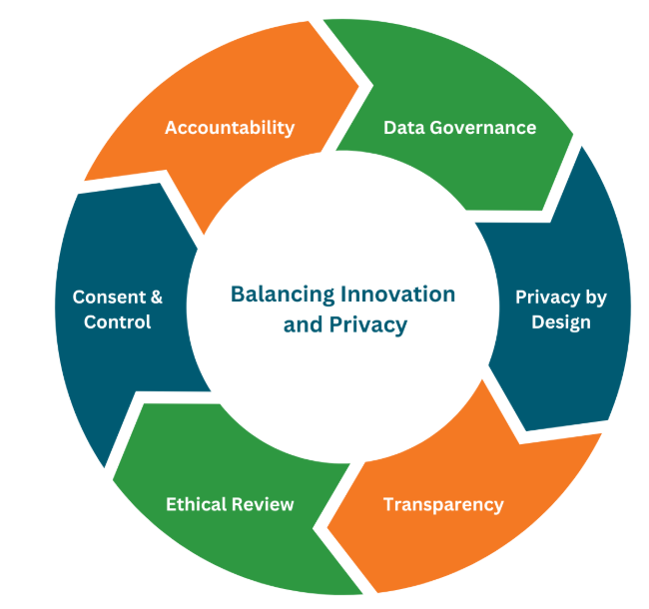
Figure 9 : Ethical considerations in data analytics
Differential privacy techniques introduce controlled statistical noise to prevent re-identification of individuals while preserving analytical usefulness. Researchers evaluate the privacy–utility trade-off to determine acceptable distortion levels. At the same time, predictive models must be examined for bias using fairness metrics such as demographic parity and equal opportunity.
Ethical data science therefore integrates technical safeguards, legal compliance, algorithm auditing, and accountability mechanisms into the broader analytics framework. Governance is not an external add-on but a foundational component of responsible data-driven innovation.

Scalable Sensor Network Design

Level 2 headings may be created by course providers in the future.

Internet of Things (IoT) research integrates sensing technologies, wireless communication, distributed analytics, and embedded system engineering to create interconnected cyber-physical systems. As the number of connected devices grows rapidly, designing scalable and reliable sensor networks becomes a central research concern.
Sensor networks consist of distributed nodes that collect environmental data and transmit it to centralized or distributed processing units. Scalability research focuses on routing algorithms capable of maintaining communication efficiency and reliability as network size expands to thousands of nodes. Efficient routing must minimize congestion while ensuring data integrity across dynamic network conditions.
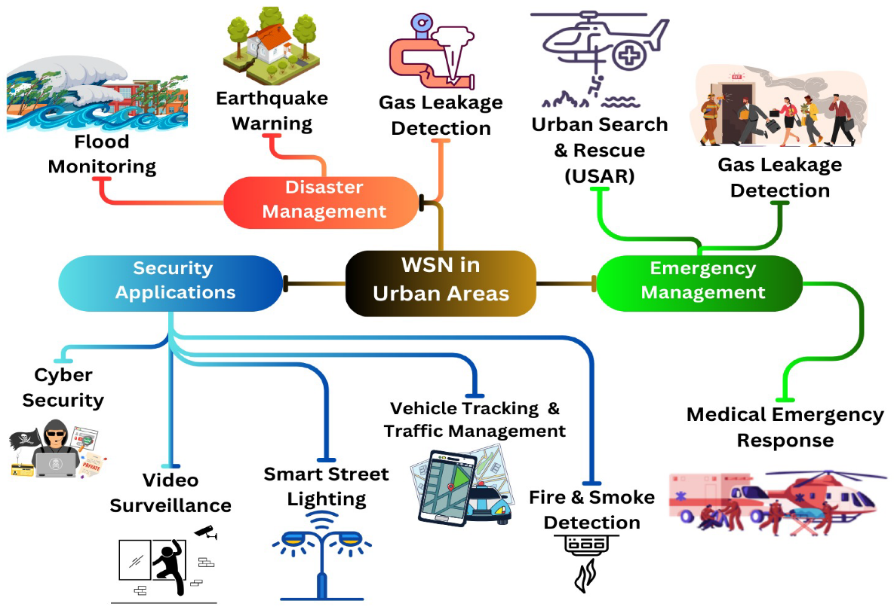
Figure 10 : Disaster, emergency, and security applications of IoT
Energy efficiency is equally critical. Many IoT devices operate on limited battery power, requiring low-power communication protocols such as Zigbee and LoRaWAN. Researchers evaluate these protocols for energy consumption, latency, and transmission reliability. Adaptive routing algorithms are designed to respond to node failures, mobility, and environmental interference without disrupting overall system performance.
Simulation environments are frequently used to model large-scale deployments under varying network densities and mobility scenarios. Reliability testing includes stress experiments measuring packet loss rates, latency variance, and communication stability. Ultimately, sustainable sensor network design depends on balancing scalability, reliability, and energy-aware architecture.

Discussion : Current Research Topics in IT

Choose at least one of the following questions and post your opinion about it on the discussion board under “Chapter 6: Current Research Topics in IT”. Alternatively, you can also add a response to one of the posts made by your classmates.
- AI systems are becoming more powerful and widely used.

    - How can universities ensure responsible use of generative AI tools?
- Cyber threats continue to evolve with new technologies.

    - Do you think prevention is more important than recovery in cybersecurity? Explain your reasoning.
- Modern computing is moving from centralized systems to cloud and edge environments.

    - What are the trade-offs between consistency and availability in distributed systems?
    - Why is energy efficiency becoming an important research topic in cloud computing?
- Large-scale data analytics creates both opportunities and risks.

    - What are the risks of collecting and analyzing massive datasets?
- The Internet of Things connects billions of devices worldwide.

    - What challenges arise when thousands of IoT devices must communicate reliably?
    - Why are lightweight encryption methods necessary in IoT systems?

Core Ethical Principles in Research

Research ethics is grounded in philosophical traditions that emphasize moral responsibility, fairness, human dignity, and harm prevention. Modern ethical standards developed in response to past research abuses and are now guided by three key principles: Respect for persons, Beneficence, and Justice.
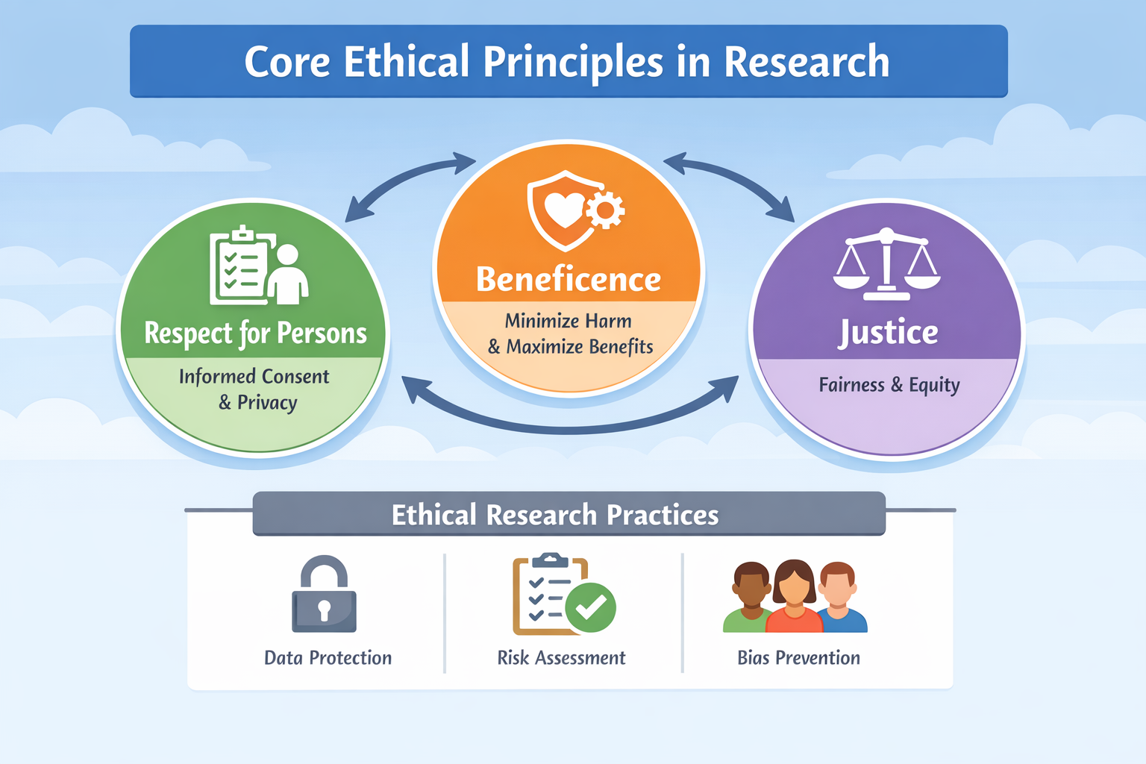
Figure 1 : Core Ethical Principles in Research
Respect for persons recognizes individual autonomy and requires voluntary participation, informed consent, and the right to withdraw. In IT research, this applies to activities such as usability testing, behavioral analytics, and data collection, where participants must clearly understand how their data will be used and protected.
Beneficence requires minimizing harm and maximizing benefits. In IT contexts, harm may include privacy breaches, bias, or misuse of data. Researchers must use safeguards such as encryption, anonymization, and risk assessment.
Justice ensures fair distribution of research risks and benefits, preventing discrimination and promoting inclusive datasets. Together, these principles guide ethical decision-making in technological research.
Chapter 7: Institutional Review and Ethical Governance

Institutional Review Boards examine research proposals involving human participants, personal data, or potentially harmful experimentation. The review process evaluates risk–benefit analysis, informed consent documentation, confidentiality protections, and safeguards for vulnerable populations.
In IT research, oversight may include evaluation of large-scale data mining studies, facial recognition experiments, biometric authentication systems, and cybersecurity penetration testing protocols. Ethical governance also addresses secondary data usage, ensuring that datasets collected for one purpose are not repurposed in ways that violate participant expectations.
Governance frameworks increasingly integrate data protection regulations, including cross-border transfer restrictions, anonymization standards, and retention policies. Institutional accountability mechanisms reinforce transparency and promote trust between researchers, institutions, participants, and society at large

Data Privacy and Confidentiality
Data-driven research frequently involves personal identifiers, behavioral traces, biometric information, location data, and communication logs. Ethical practice requires strict anonymization, encryption, controlled access protocols, and compliance with legal standards.
Privacy breaches may result in financial harm, reputational damage, identity theft, or psychological distress. Ethical research therefore emphasizes data minimization—collecting only necessary information—and implementing secure storage architectures with audit trails and access controls.
Advanced privacy-preserving technologies such as differential privacy, homomorphic encryption, and secure multi-party computation aim to enable statistical analysis without exposing raw personal data. These techniques represent active research frontiers that balance analytical value with confidentiality.
Researchers must also consider contextual privacy expectations. Publicly available data are not automatically ethically permissible for unrestricted research use. Ethical evaluation requires attention to reasonable user expectations, consent boundaries, and contextual integrity.

Algorithmic Bias and Fairness

Machine learning systems may replicate and amplify societal biases embedded within training datasets. Algorithmic bias can result in discriminatory outcomes in hiring, lending, predictive policing, health diagnostics, and educational admissions.
Ethical research requires implementation of fairness metrics, bias detection methodologies, and inclusive dataset construction. Fairness definitions include demographic parity, equalized odds, predictive parity, and counterfactual fairness. Each definition reflects different ethical priorities and trade-offs.
Bias mitigation strategies may involve re-sampling imbalanced datasets, reweighting training examples, modifying optimization objectives, or post-processing decision outputs. Transparency tools such as model interpretability frameworks and fairness dashboards support accountability.
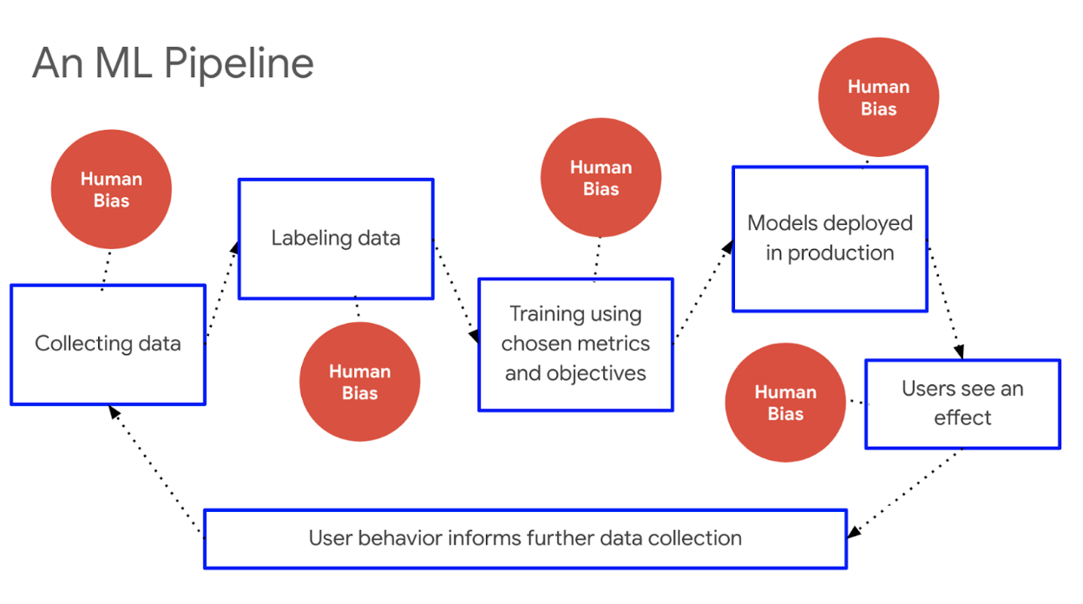
Figure 2 : Algorithmic Fairness Framework: Bias Detection and Mitigation Strategies
Responsible AI research recognizes that fairness is not purely technical but also social and contextual. Ethical AI design requires interdisciplinary collaboration among technologists, legal scholars, ethicists, and social scientists.

Security Research and Dual-Use Concerns

Cybersecurity research frequently involves identifying system vulnerabilities and simulating attacks to strengthen defenses. However, publishing exploit techniques may inadvertently facilitate malicious actors.
Responsible disclosure protocols require notifying affected organizations before public release of vulnerabilities, allowing remediation. Ethical guidelines balance transparency with harm prevention.
Dual-use research refers to work that may serve both beneficial and harmful purposes. For example, advances in cryptography enhance privacy but may complicate lawful investigations. Research in artificial intelligence may improve automation but also enable surveillance or autonomous weapons systems.
Ethical evaluation must anticipate downstream consequences and incorporate risk modeling, publication review, and stakeholder consultation. Researchers bear responsibility for considering how innovations may be misused.

Plagiarism, Intellectual Property and Data Fabrication

Plagiarism and Intellectual Property
Plagiarism involves presenting others’ ideas, text, data, or code without appropriate attribution. In IT research, plagiarism may include copying software modules, reusing datasets without acknowledgment, or incorporating algorithmic designs without citation.
Proper citation practices support intellectual transparency and enable reproducibility. Intellectual property law further regulates ownership of code, software patents, and database rights.
Open-source licensing introduces additional responsibilities regarding redistribution, derivative works, and attribution requirements. Researchers must understand license compatibility when integrating external code libraries.

Data Fabrication and Falsification
Fabrication refers to inventing data that were never collected. Falsification involves altering data, selectively omitting observations, or manipulating statistical results to align with hypotheses.
Such misconduct undermines scientific credibility, wastes resources, and may cause societal harm if flawed findings influence technology deployment. In IT contexts, falsified security benchmarks or manipulated AI performance metrics could mislead policymakers and industry practitioners.
Safeguards include transparent documentation, data sharing for replication, peer review, independent auditing, and adherence to reproducible research standards.

Authorship and Collaborative Ethics

Collaborative research requires fair attribution of intellectual contributions. Authorship should reflect substantive involvement in conceptual design, data analysis, drafting, or interpretation—not merely institutional seniority.
Clear communication regarding roles, responsibilities, and order of authorship prevents disputes. Ethical collaboration also requires transparency in funding disclosures, conflict-of-interest reporting, and acknowledgment of technical assistance.


Emerging Ethical Challenges in Advanced IT

Autonomous Systems and Accountability
Autonomous AI systems make decisions without direct human intervention in domains such as healthcare, transportation, and financial services. Determining accountability when errors occur presents complex ethical and legal challenges.
Research explores human-in-the-loop frameworks, algorithm auditing systems, traceability mechanisms, and liability attribution models. Explainable AI aims to provide interpretable reasoning behind automated decisions, enhancing accountability.
Ethical governance must clarify responsibility among developers, deployers, operators, and institutions.

Surveillance Technologies and Digital Rights
Mass data collection enables predictive analytics but raises civil liberties concerns. Facial recognition, biometric tracking, and large-scale monitoring technologies may infringe upon privacy rights and freedom of expression.
Ethical evaluation must balance security objectives with proportionality, necessity, and human rights considerations. Oversight mechanisms, transparency reporting, and independent audits support responsible deployment.
Digital rights frameworks increasingly inform IT research ethics.
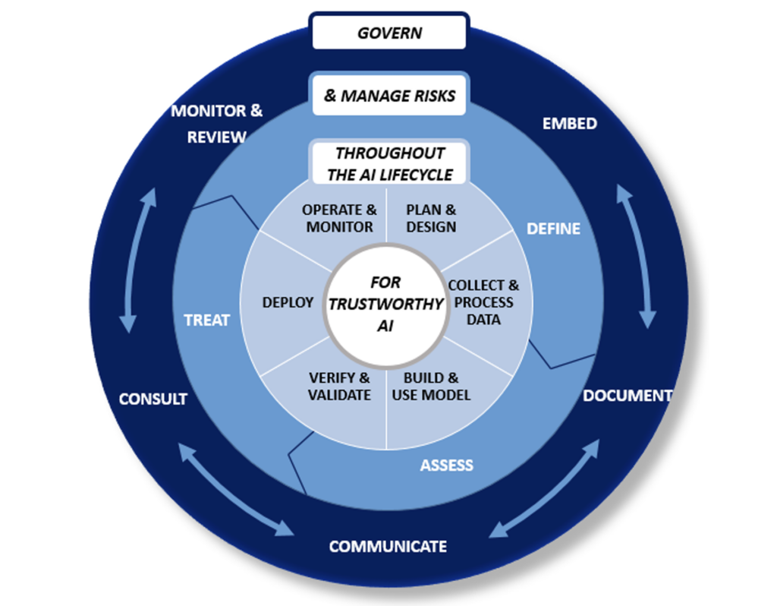
Figure 5 : Surveillance Technologies and Digital Rights Governance Model

Sustainability and Environmental Responsibility

Large-scale computational systems consume substantial energy. Training advanced AI models requires extensive computational resources, contributing to carbon emissions.
Sustainable computing research integrates energy-efficient algorithm design, hardware optimization, and carbon footprint assessment into technological development. Lifecycle assessment evaluates environmental impact from production to disposal of computing infrastructure.
Environmental responsibility represents an expanding dimension of research ethics, linking innovation with ecological stewardship.

What Are the Ethical Considerations of Emerging Technologies?

Discussion : Ethics in Research

Level 2 headings may be created by course providers in the future.
Choose at least one of the following questions and post your opinion about it on the discussion board under “Chapter 7: Ethics in Research”. Alternatively, you can also add a response to one of the posts made by your classmates.

    - What safeguards are necessary to balance transparency and security in cybersecurity research?
    - How can institutions detect and prevent research misconduct effectively?
    - What accountability mechanisms are appropriate for autonomous systems?
    - How does environmental sustainability redefine ethical responsibility in computing research?
You can click here to go to the discussion page.

Evaluating an Ethical Challenge in IT Research

Assignment Instruction
Select one of the following ethical issues discussed in this chapter, such as:

    - Data privacy and confidentiality
    - Dual-use concerns in cybersecurity or AI
    - Academic integrity (plagiarism, fabrication, authorship)
    - Surveillance technologies and digital rights
    - Sustainability and environmental responsibility
    - Autonomous systems and accountability
Answer each of the following questions. The answers to each question should be provided only in the designated space just below the questions.

